Experiment No .: 1

1. Title: Demonstrate inline, internal, and external
JavaScript; use console methods; create a webpage
showing user info and a welcome message.

2. Software/Tools Required: Visual Studio Code (VS
Code)Google Chrome/web browser, HTML, JavaScript.

3. Theory: JavaScript is a scripting language used to make web
pages interactive.
It can be added in three ways:
● Inline JavaScript: Written inside HTML elements.
● Internal JavaScript: Written inside the <script> tag in the
HTML file.
● External JavaScript: Written in a separate .js file and linked
to the HTML page.
● Console methods like console.log(), console.info(), console.warn(), and console.error() are used for debugging and displaying messages.

4. Output:
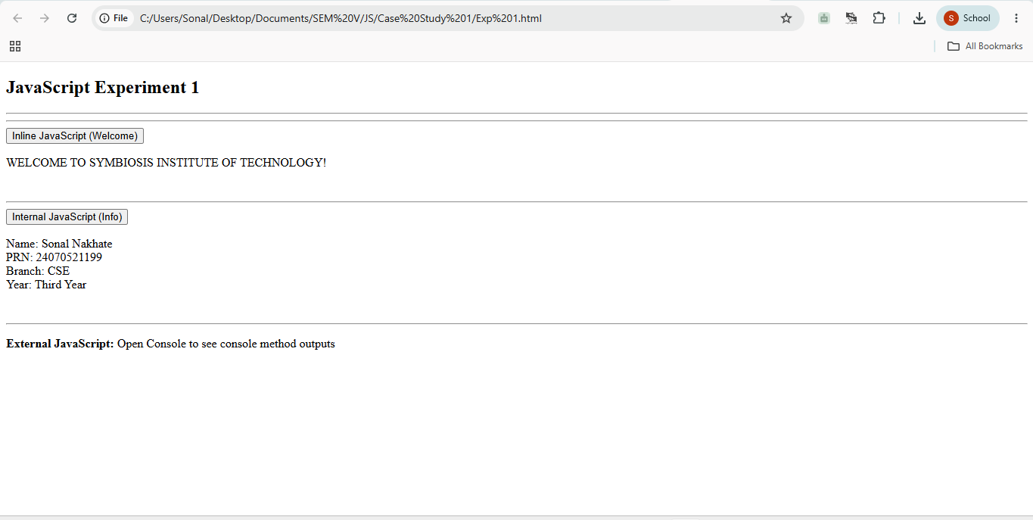

5. Result/Conclusion: The experiment was performed successfully. A webpage displaying a welcome message and user information was created using inline, internal, and external JavaScript, and console methods were demonstrated
successfully.

Case Study No.: 1

1. Case Study Title: Create a webpage for the college department and link the student information page with it. Write a JavaScript program to display "Welcome to SIT Nagpur" in an alert box.

2. Case Study Program Code:
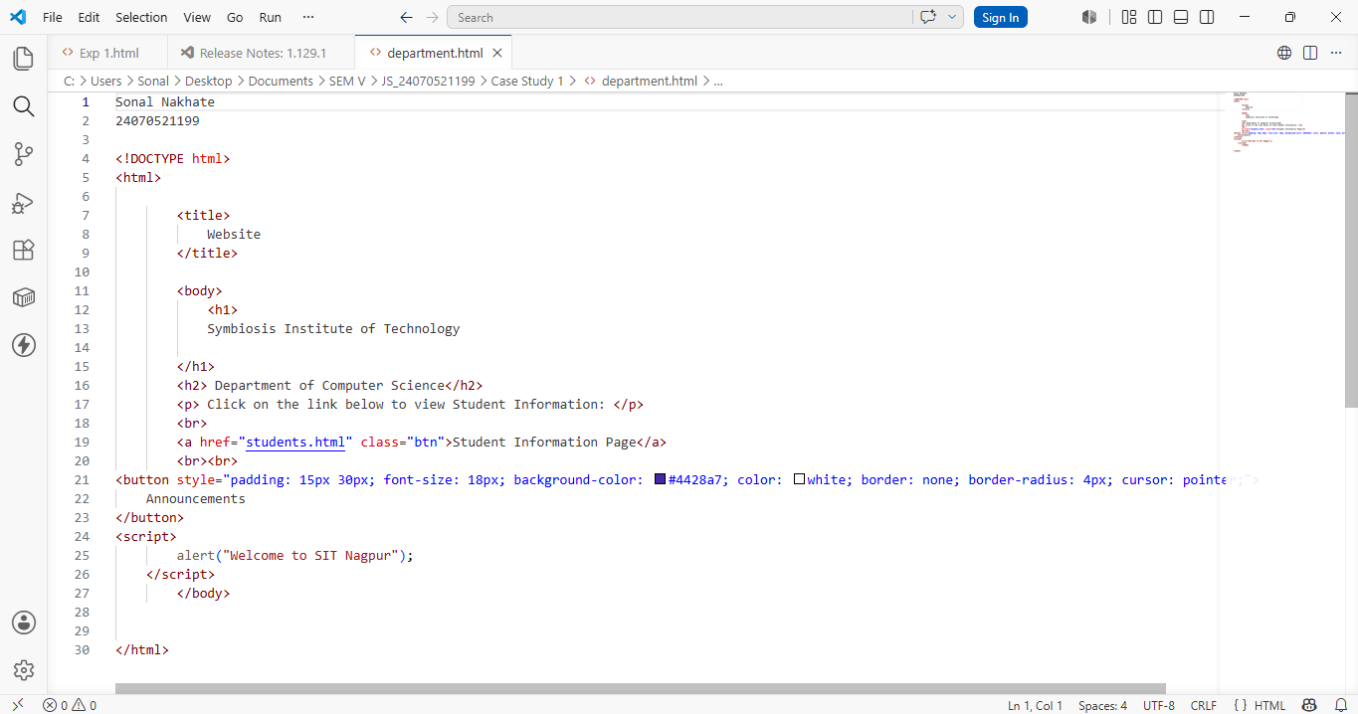

3. Output:
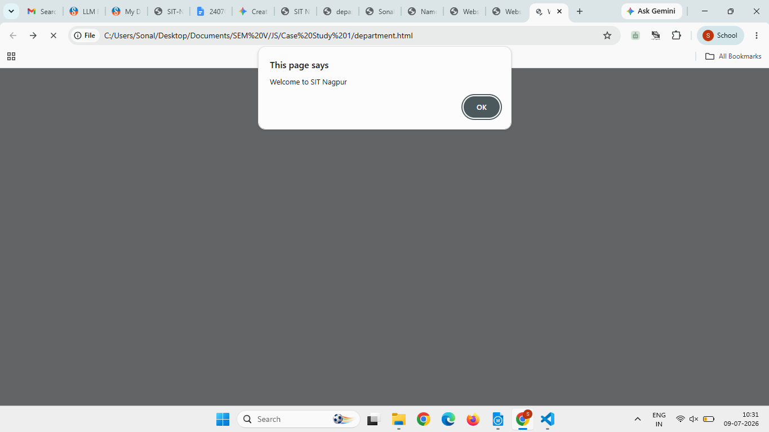
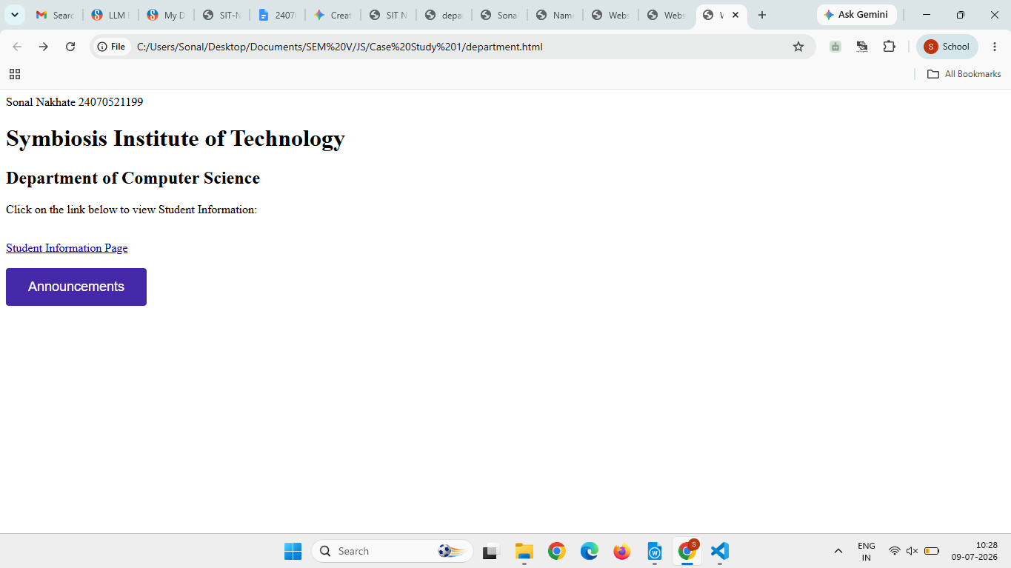

4. Result/Conclusion: The college department webpage was created successfully. The Student Information page was linked to it, and JavaScript was implemented using inline, internal, and external methods. A welcome message was displayed in an alert box, and output was verified in the browser console.

Experiment No.: 2

1. Title: Use var, let, const, and demonstrate basic features like
template literals and destructuring; build a billing calculator
with user input.

2. Software/Tools Required: Visual Studio Code (VS Code), web
browser, HTML, JavaScript.

3. Theory: var is function-scoped, let is block-scoped, and const is used for fixed values.
The prompt() function accepts user input, and Number() converts input into numeric values.
The program calculates the total amount, GST, and final bill using arithmetic operations.
An object stores all billing details together, while object
destructuring extracts required values easily.
Template literals (``) are used to display formatted output with variable values using ${}.
The document.write() method displays the billing receipt on the webpage.

4. Output: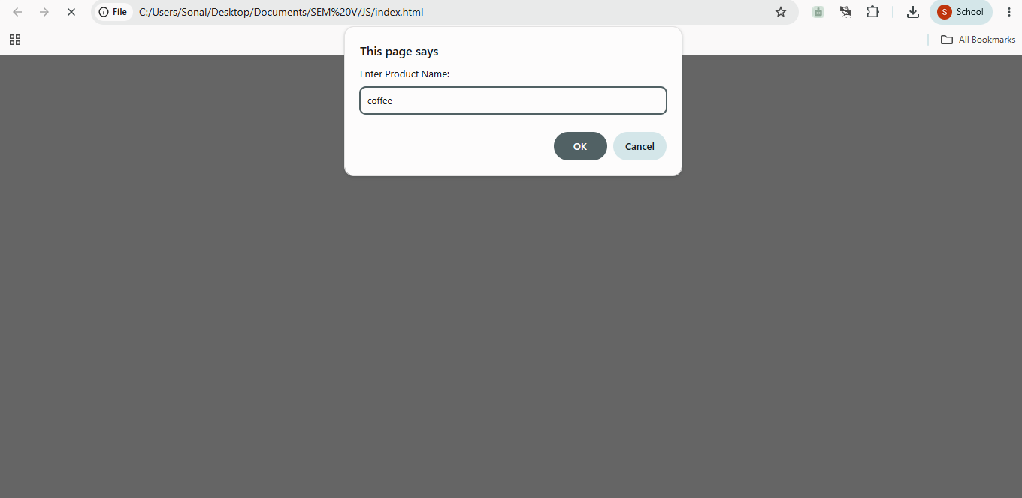
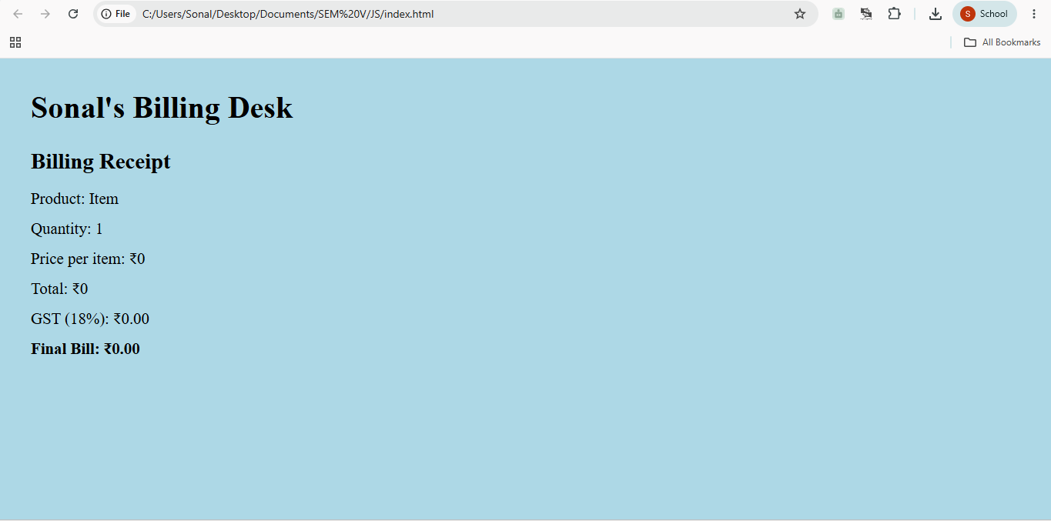
5. Result/Conclusion: A billing calculator was successfully created using JavaScript. The program accepted user input, calculated the bill with GST, and demonstrated the use of var, let, const, template literals, and object destructuring
effectively.

Case Study No.: 2

1. Case Study Title: Develop the webpage for an online shopping website using HTML, CSS, and HTML tags and calculate the bill, customer name, mobile number, invoice number, product number, quantity (kg), rate per kg, discount, GST, packing charges, payment mode (cash/card/UPI), and membership (yes/no).

2. Case Study Program Code:
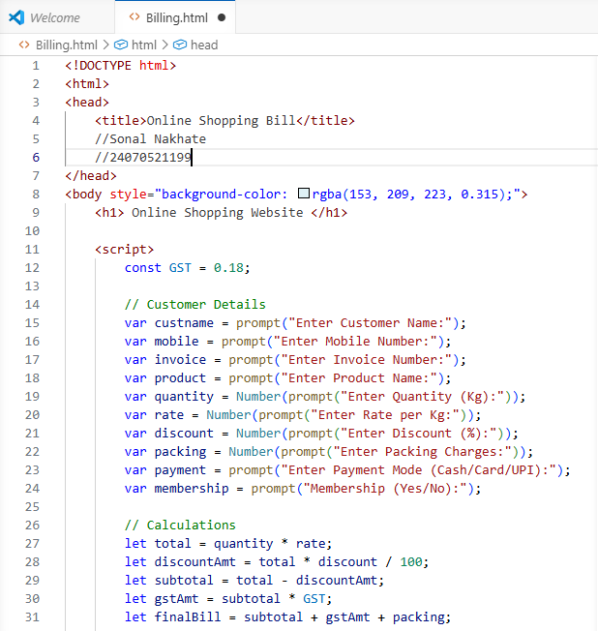
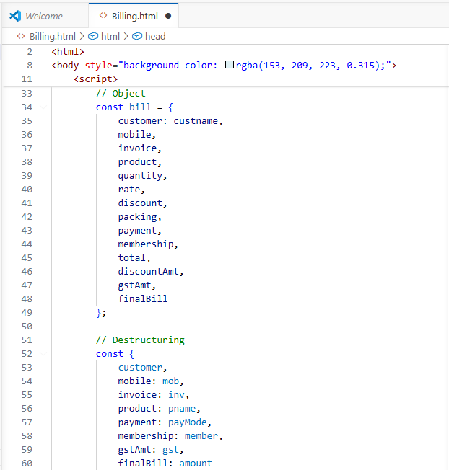
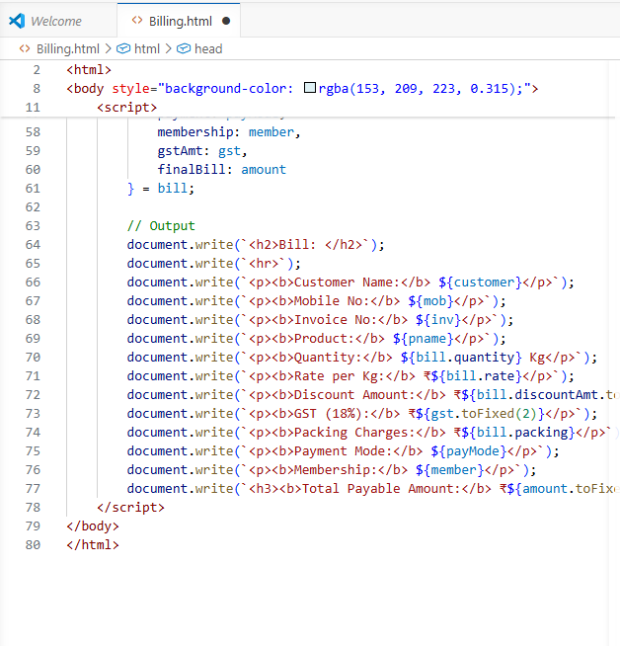

3. Output:
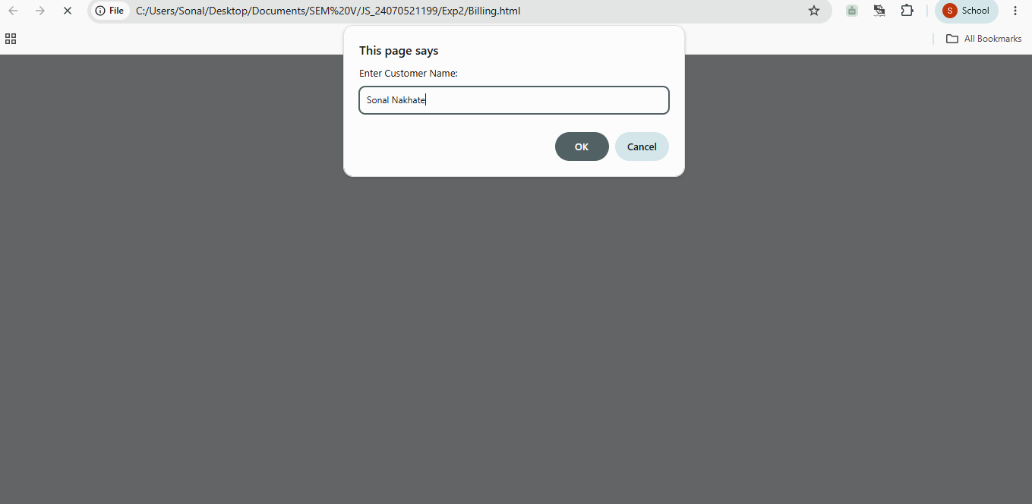
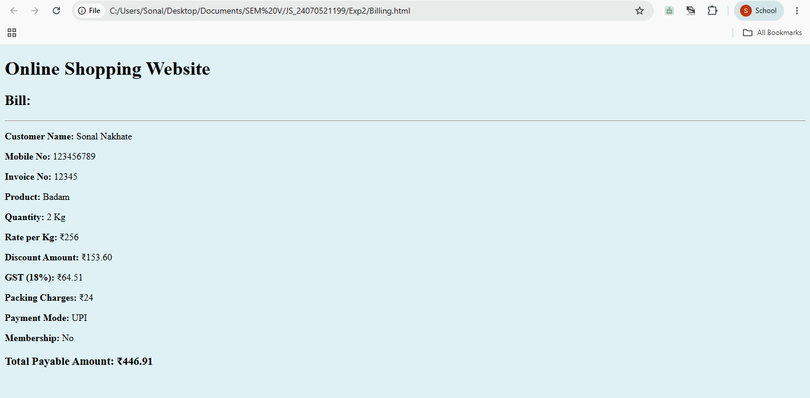

4. Result/Conclusion: The online shopping billing webpage was successfully developed using HTML, CSS, and JavaScript. The program accepted customer and product details; calculated the total bill, including discount, GST, and packing charges; and displayed the final invoice correctly. It demonstrated the use of user input, arithmetic calculations, objects, template literals, and object destructuring in JavaScript.

Experiment No.: 3

1. Title: Implement control structures and form validation. Create a grading system based on user-entered marks.

2. Software/Tools Required: Visual Studio Code (VS
Code) Google Chrome/web browser, HTML, JavaScript.

3. Theory:

A. Form Validation
Ensures user input is accurate and valid before processing.
- Empty Check: Ensures the input field is not blank.
- Type Check: Ensures input is a number using isNaN().
- Range Check: Restricts marks within valid bounds.

B. Control Structures (if...else if...else)
Executes specific blocks of code depending on whether conditions evaluate to true or false. Used to map mark ranges to grades.

C. DOM Manipulation
- Input: document.getElementById('marks').value (Reads input).
- Output: document.getElementById('result').innerText (Displays output).

4. Output:
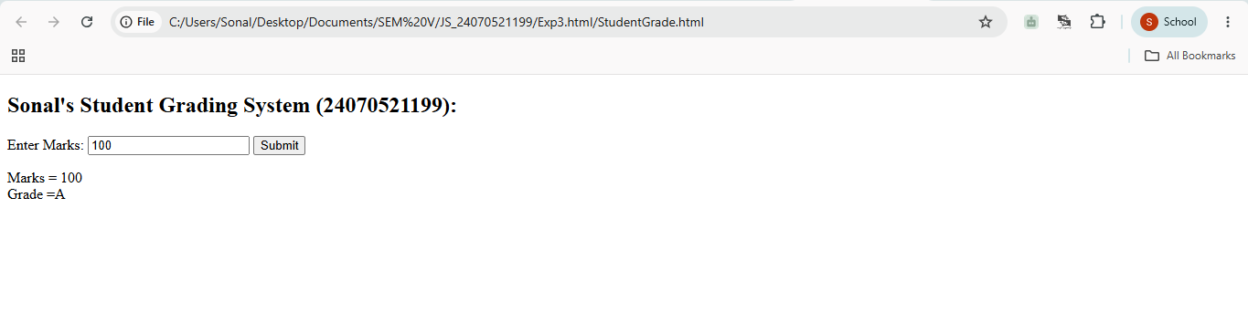
5. Result/Conclusion: By using control structures (if...else if) alongside form validation techniques, web applications can accurately process user inputs, prevent faulty data processing, and produce dynamic, real-time results such as student grading reports.

Case Study No.: 3

1. Case Study Title: Write a JavaScript program that accepts student marks and displays the scholarship category.

2. Case Study Program Code:
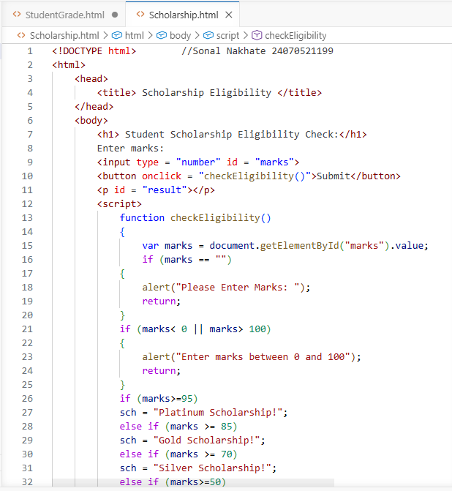
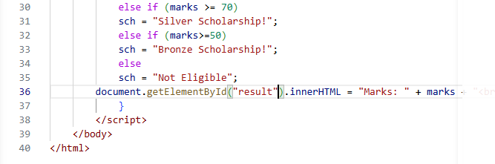

3. Output:
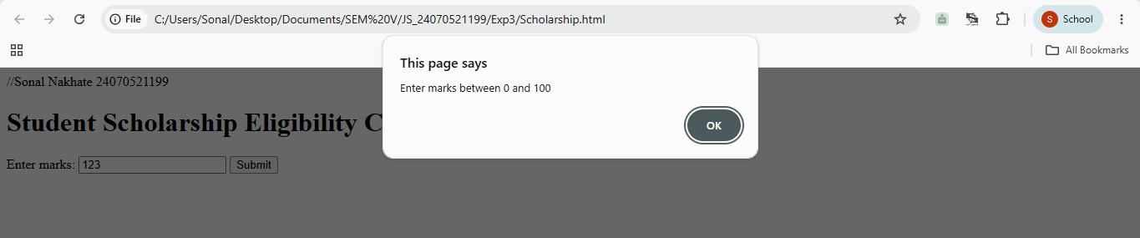
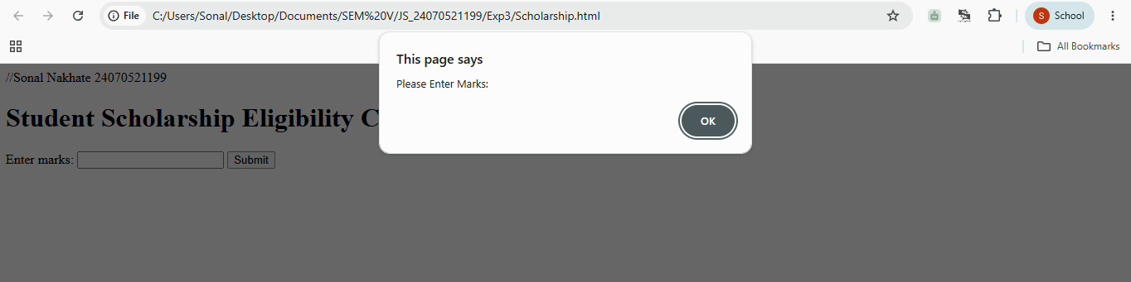
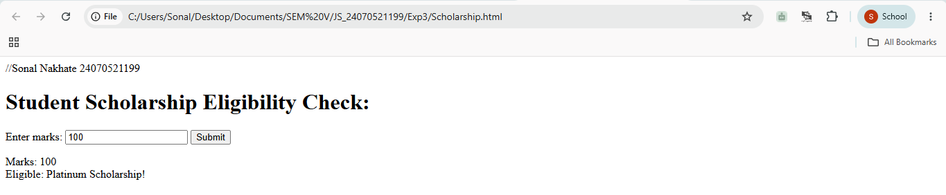
4. Result/Conclusion: We have successfully implemented a simple JavaScript program that checks scholarship eligibility based on marks scored by the student.

Experiment No.: 4
1. Title: Use function types, scope, and closures; apply try-catch; build a palindrome checker.
2. Software/Tools Required: Visual Studio Code (VS Code) Google Chrome/web browser, HTML, JavaScript.
3. Theory:
Function Types: Demonstrates anonymous functions (assigned directly to variables without a name) and arrow functions (concise ES6 => syntax).
Scope: Differentiates between global variables (accessible throughout the script) and local variables (restricted to the block
or function where they are declared).
Closures: Occurs when an inner function retains access to its parent function's scope, preserving state variables (like count) even after the outer function finishes executing.
Error Handling: Uses try...catch and throw statements to validate input types and gracefully handle runtime exceptions without crashing the program.
Palindrome Algorithm: A string is split into an array of characters, reversed, joined back into a string, and compared against the original input using strict equality (===).
4. Output:
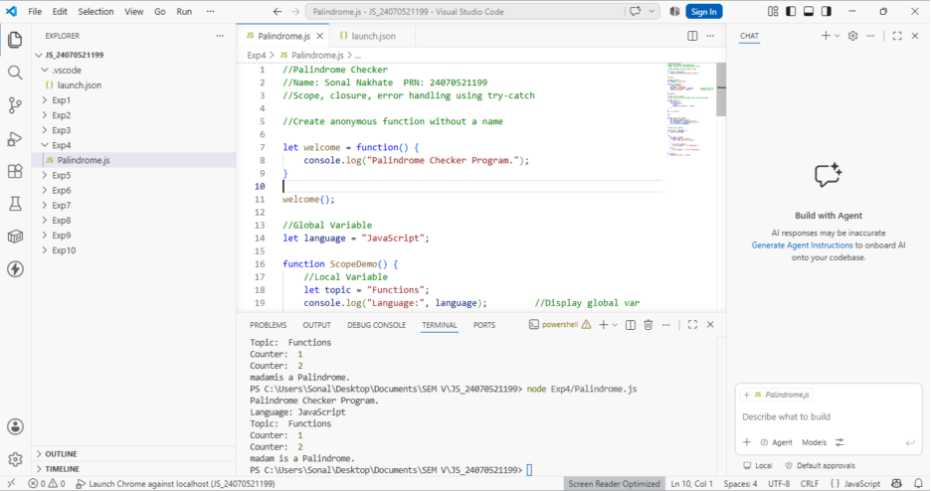

5. Result/Conclusion: In this experiment, fundamental JavaScript concepts—including anonymous/arrow functions, scope rules, closures, and try...catch error handling—were successfully implemented. Using these techniques alongside array manipulation methods (split, reverse, join), a functional and error-resistant palindrome checker was constructed.

Case Study No.: 4
1. Case Study Title: ATM Card Pin Verification using JavaScript Functions Case Study.
2. Case Study Program Code:
// Global Scope: System configurations //Name: Sonal Nakhate PRN: 24070521199 const BANK_NAME = "Global Secure Bank"; let dailyAttemptsLimit = 3;

// 1. FUNCTION DECLARATION: Reverses a PIN string or number function reversePin(pin) {
const pinString = String(pin);
const reversed = pinString.split("").reverse().join(""); return reversed;
}

// 2. FUNCTION EXPRESSION: Checks if a PIN is a palindrome const isPalindromePin = function(pin) {
const pinString = String(pin);
const reversedPin = reversePin(pinString); return pinString === reversedPin;
};
// 3. ARROW FUNCTION: Formats output messages based on verification const generateSecurityAlert = (pin, isPalindrome) => {
if (isPalindrome) {
return `[SPECIAL SECURITY PROTOCOL]: PIN ${pin} is a Palindrome. High-symmetry alert triggered. Proceeding to main menu...`;

return `[STANDARD SECURITY]: PIN ${pin} verified successfully. Proceeding to main menu...`;
};

// 4. SCOPE DEMONSTRATION: Verification Handler function processATMTransaction(enteredPin) {
let attemptCounter = 1;

console.log(`--- Processing PIN verification at ${BANK_NAME} ---`);

if (attemptCounter <= dailyAttemptsLimit) {
const isPalindromic = isPalindromePin(enteredPin);
const securityMessage = generateSecurityAlert(enteredPin, isPalindromic);
console.log(securityMessage);

// FIXED OBJECT RETURN: Comma added after true return success: true,
isPalindrome: isPalindromic };
} else {
console.log("Account locked. Exceeded daily limits."); return {
success: false, isPalindrome: false
};
}
}
//Execution processATMTransaction(1221); processATMTransaction(4821);

3. Output:
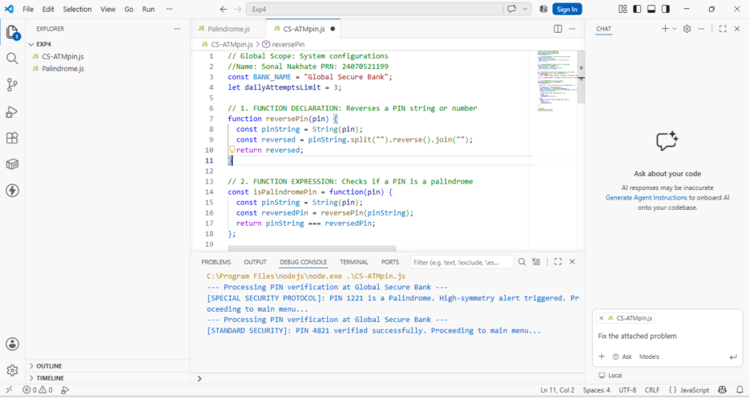

4. Result/Conclusion: We have successfully implemented a simple JavaScript program that checks if the ATM pin is a palindrom or not.

Experiment No.: 5

1. Title: Apply array methods and object handling; create a cart total calculator with discount logic.

2. Software/Tools Required: Visual Studio Code (VS
Code), JavaScript.

3. Theory:
JavaScript objects allow storing collections of data using key-value pairs (e.g., name, price, quantity), while arrays store ordered lists of these objects. Higher-order array methods such as reduce() process elements systematically without standard explicit loops. The reduce() method executes a reducer function on each array element, accumulating values to compute a single output—such as the total cost of all products. Conditional statements (if-else or ternary operators) evaluate business logic, such as applying a 10% discount if the cart's total exceeds a specific threshold.

4. Output:
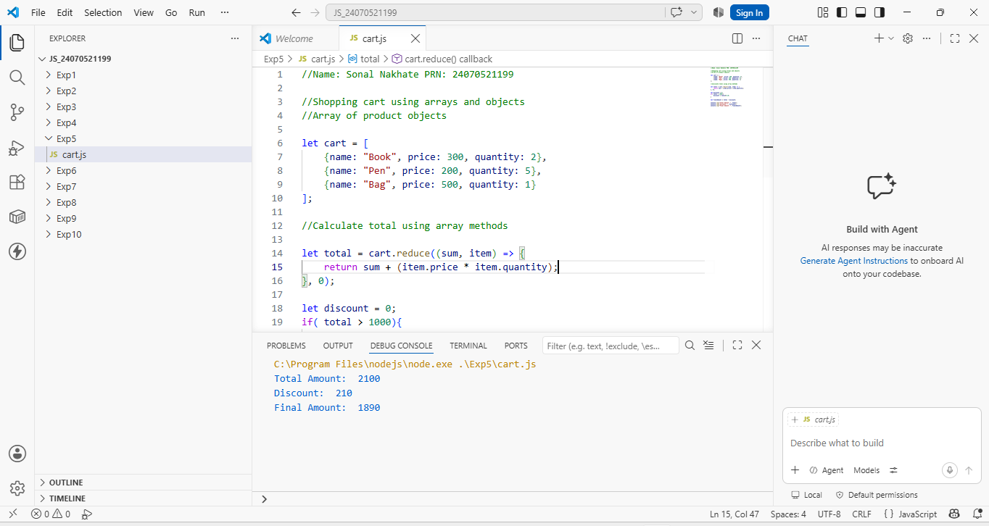
5. Result/Conclusion: The experiment was performed successfully. JavaScript arrays, objects, and higher-order array methods (specifically reduce()) were demonstrated to process structured data efficiently. Conditional logic for applying discounts was implemented, and the final output was verified using browser console.log() methods.

Case Study No.: 5

1. Case Study Title: To study the functioning of arrays and loops in JavaScript.
Create and manipulate arrays: push, pop, shift, unshift, splice, slice.
Use array methods: map(), filter(), reduce(), and forEach().
Create an array of numbers and find the maximum and minimum values.

2. Case Study Program Code:
//Sonal Nakhate 24070521199

// 1. Create an Array
let fruits = ["apple", "banana", "cherry"];

// push() - Adds an element to the END
fruits.push("mango");
// Result: ["apple", "banana", "cherry", "mango"]

// pop() - Removes the LAST element
let lastFruit = fruits.pop();
// Result: ["apple", "banana", "cherry"] | Removed: "mango"

// unshift() - Adds an element to the BEGINNING
fruits.unshift("strawberry");
// Result: ["strawberry", "apple", "banana", "cherry"]

// shift() - Removes the FIRST element
let firstFruit = fruits.shift();
// Result: ["apple", "banana", "cherry"] | Removed: "strawberry"

// splice(startIndex, deleteCount, ...itemsToAdd) - Modifies original array (Mutates)
// Example: Remove 1 element at index 1 and insert "grape"
fruits.splice(1, 1, "grape");
// Result: ["apple", "grape", "cherry"]

// slice(startIndex, endIndex) - Extracts a portion WITHOUT modifying original (Non-mutating)
// Note: endIndex is non-inclusive
let subArray = fruits.slice(0, 2);
// subArray: ["apple", "grape"]
// fruits stays: ["apple", "grape", "cherry"]

const numbers = [1, 2, 3, 4, 5, 6];

// 1. forEach() - Executes a function once for each array element (returns nothing)
numbers.forEach((num) => {
console.log(`Item: ${num}`);
});

// 2. map() - Creates a NEW array by transforming every element
const doubled = numbers.map((num) => num * 2);
// Result: [2, 4, 6, 8, 10, 12]

// 3. filter() - Creates a NEW array with elements that satisfy a condition
const evens = numbers.filter((num) => num % 2 === 0);
// Result: [2, 4, 6]

// 4. reduce() - Accumulates array elements down to a SINGLE value
// Syntax: array.reduce((accumulator, currentValue) => ..., initialValue)
const sum = numbers.reduce((acc, curr) => acc + curr, 0);
// Result: 21

const nums = [42, 7, 89, 12, 3, 99, 23];

const maxVal = Math.max(...nums); // 99
const minVal = Math.min(...nums); // 3

console.log(`Max: ${maxVal}, Min: ${minVal}`);

3. Output:
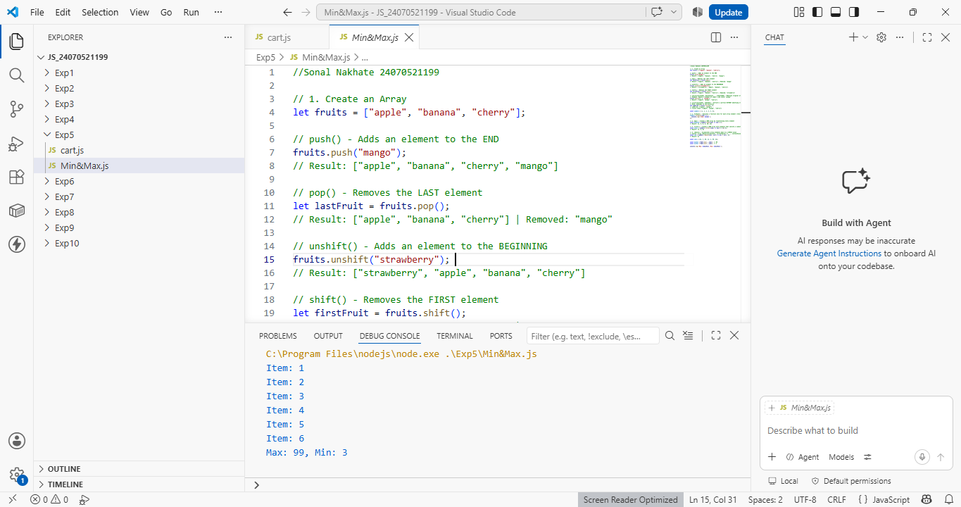

4. Result/Conclusion: This experiment demonstrated the core mechanics of JavaScript arrays and iterative processing. Highlighting how different methods handle data manipulation, transformation, and evaluation. Modifying arrays using push(), pop(), shift(), unshift(), splice(), and slice() established a practical understanding of element positioning and the distinction between mutating original data versus returning new copies. Furthermore, utilizing functional array methods like forEach(), map(), filter(), and reduce() illustrated a clean, declarative alternative to traditional looping for transforming and aggregating data. Finally, calculating the maximum and minimum values of a number array using Math.max()/Math.min() with the spread operator, reduce(), and classic for loops demonstrated how algorithmic logic and modern language features can solve fundamental computational problems efficiently.

Experiment No.: 6

1. Title: Use string functions and regex for email validation, data extraction, and text analysis.

2. Software/Tools Required: Visual Studio Code (VS
Code), JavaScript.

3. Theory: This JavaScript snippet demonstrates core string manipulation and regular expression techniques used for text processing.
Email Validation: Using anchored RegEx patterns (^...$) with .test(), we verified whether a standalone string follows standard email formatting constraints before accepting user input.
Data Extraction: By leveraging pattern matching with global flags (/g) and .match(), we automatically scanned unstructured blocks of text to locate and extract embedded email addresses.
Text Analysis: Combining String methods (.toLowerCase(), .split(), .length) allowed us to analyze key structural details of text, including total character length, word counts, case transformations, and specific keyword occurrences.

4. Output:
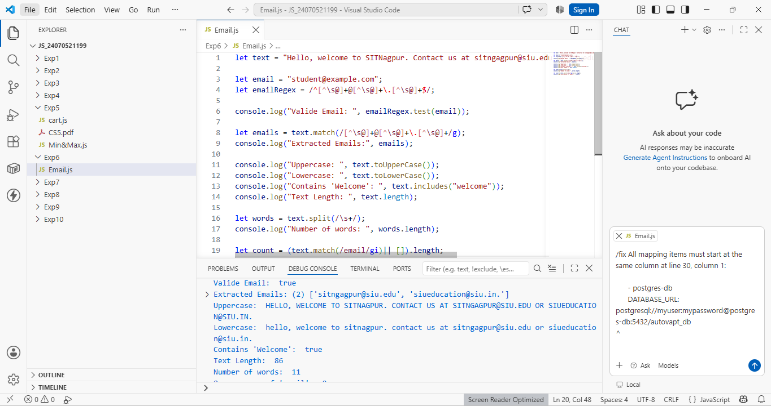

5. Result/Conclusion: Through this experiment, we successfully demonstrated the application of JavaScript string functions and regular expressions for performing essential text-processing tasks.
In conclusion, combining regular expressions with built-in string methods provides a robust, scalable approach to data parsing, validation, and analytics in JavaScript applications.

Case Study No.: 6

1. Case Study Title: To demonstrate JavaScript string operations using substring(), indexOf(), split(), replace(), string reversal, and vowel counting based on user input.

2. Case Study Program Code:
<!DOCTYPE html>
<html>
<head>
<title>String Operations</title>

<style>
body {
background-color: rgb(239, 171, 243);
font-family: Arial, sans-serif;
padding: 20px;
}

input {
padding: 8px;
margin: 5px 0 15px 0;
width: 350px;
display: block;
}

textarea {
padding: 10px;
margin: 5px 0 15px 0;
width: 500px;
height: 80px;
display: block;
}

button {
padding: 10px 20px;
margin: 10px 0;
cursor: pointer;
}

#output {
margin-top: 20px;
font-size: 18px;
line-height: 1.6;
}
</style>
</head>

<body>

<h2>Sonal's JavaScript String Operations</h2>

<label for="str">Enter String:</label>
<textarea id="str" placeholder="Enter your string or paragraph"></textarea>

<label for="start">Substring Start Index:</label>
<input type="number" id="start" placeholder="Enter start index (e.g., 0)">

<label for="end">Substring End Index:</label>
<input type="number" id="end" placeholder="Enter end index">

<label for="search">IndexOf - Enter text to search:</label>
<input type="text" id="search" placeholder="Enter character or word">

<label for="separator">Split - Enter separator:</label>
<input type="text" id="separator" placeholder="Type a character or 'space'">

<label for="oldText">Replace - Text to replace:</label>
<input type="text" id="oldText" placeholder="Enter text to replace">

<label for="newText">Replace - New text:</label>
<input type="text" id="newText" placeholder="Enter new text">

<button onclick="performOperations()">Perform Operations</button>

<div id="output"></div>

<script>
function performOperations() {
let str = document.getElementById("str").value;

if (!str) {
document.getElementById("output").innerHTML = "<strong>Please enter a valid string first!</strong>";
return;
}

let start = Number(document.getElementById("start").value);
let end = Number(document.getElementById("end").value);

let search = document.getElementById("search").value;
let separator = document.getElementById("separator").value;

let oldText = document.getElementById("oldText").value;
let newText = document.getElementById("newText").value;

let output = "";

// Substring (Handles cases where end index isn't specified)
let subResult = (end > 0) ? str.substring(start, end) : str.substring(start);
output += "<strong>Substring:</strong> " + subResult + "<br>";

// IndexOf
if (search) {
output += "<strong>Index of '" + search + "':</strong> " + str.indexOf(search) + "<br>";
}

// Split
if (separator) {
let sepChar = (separator === "space") ? " " : separator;
output += "<strong>Split:</strong> [" + str.split(sepChar).join(", ") + "]<br>";
}

// Replace (Replaces all instances safely)
if (oldText) {
output += "<strong>Replace:</strong> " + str.replaceAll(oldText, newText) + "<br>";
}

// Reverse
let reverse = str.split("").reverse().join("");
output += "<strong>Reversed String:</strong> " + reverse + "<br>";

// Count Vowels (Using regex for cleaner execution)
let vowelMatch = str.match(/[aeiou]/gi);
let count = vowelMatch ? vowelMatch.length : 0;

output += "<strong>Number of Vowels:</strong> " + count;

document.getElementById("output").innerHTML = output;
}
</script>
</body>
</html>

3. Output:
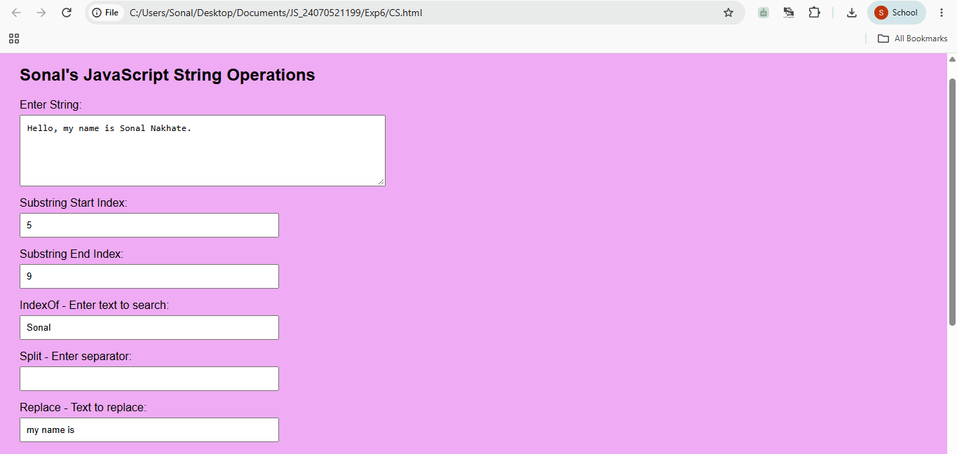
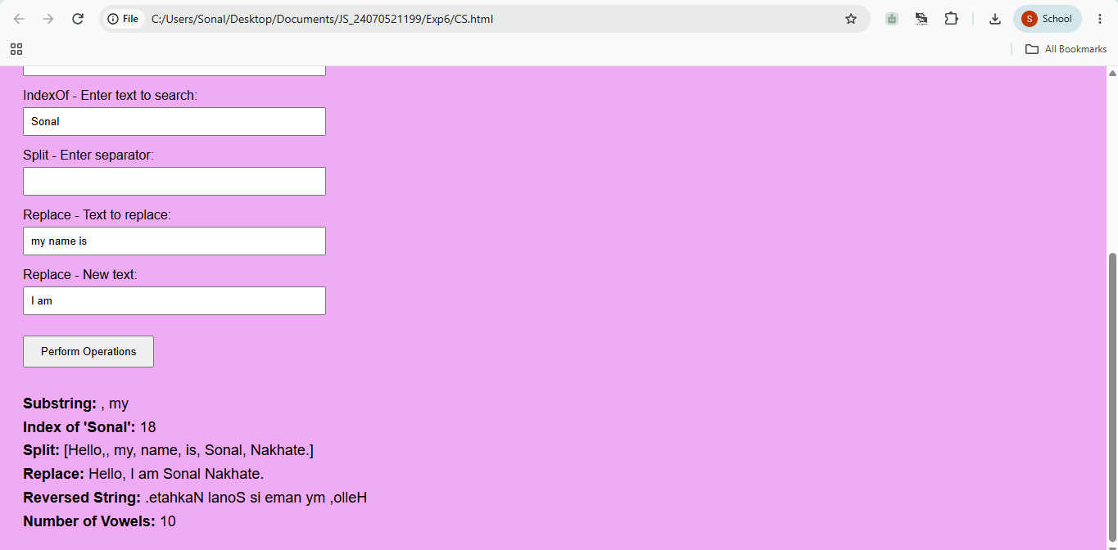

4. Result/Conclusion: Thus, various JavaScript string operations were successfully performed, including substring extraction, text searching, splitting, replacing, reversing, and vowel counting, and the results were displayed dynamically on the webpage.

Experiment No.: 7

1. Title: Perform DOM traversal and updates; develop a to-do list app with add, edit, and delete features.

2. Software/Tools Required: Visual Studio Code (VS
Code), HTML, CSS, JavaScript.

3. Theory: DOM (Document Object Model) traversal and manipulation allow JavaScript to dynamically select, structure, and modify webpage content without requiring a full page refresh.
- DOM Traversal: Involves navigating through parent, child, and sibling nodes using methods like getElementById(), createElement(), and appendChild().
- Dynamic DOM Updates: Enables creating elements on the fly (createElement('li')), assigning inline/CSS classes (classList.toggle('completed')), and removing elements from the node tree (li.remove()).
- Event Handling: Listens for user interactions (click, keypress) using addEventListener() to trigger functions that mutate the structure and appearance of the page in real time.

4. Output:
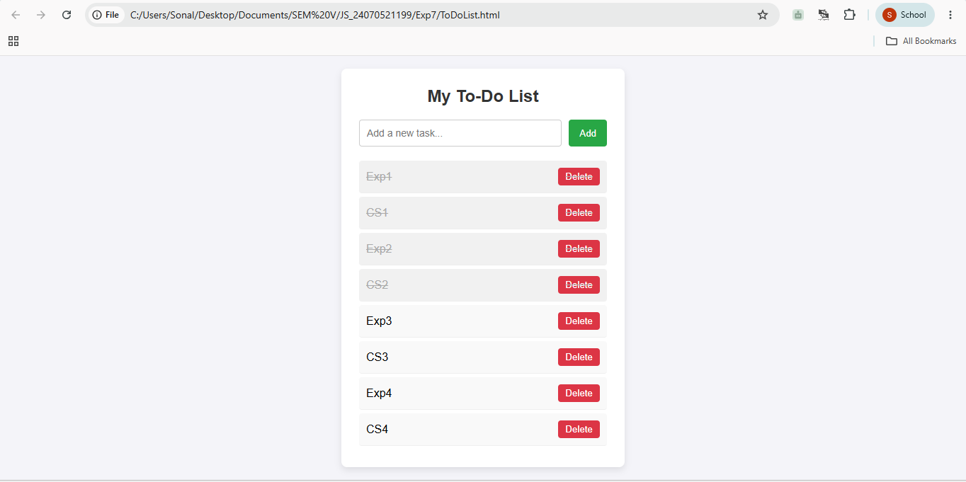

5. Result/Conclusion: The To-Do List application demonstrates how JavaScript interacts with the DOM tree to construct interactive web interfaces. By combining event listeners with DOM traversal, creation, and deletion methods, the application handles user inputs, dynamically updates task statuses, and modifies the DOM structure seamlessly.

Case Study No.: 7

1. Case Study Title: To demonstrate events handling in javascript, a) access and manipulate from elements using javascript. b) validate user input (eg. email,empty,fields) c) use various form events (submit,change,focus).

2. Case Study Program Code:
//Sonal Nakhate 24070521199

<!DOCTYPE html>
<html>
<head>
<title>Sonal's - Event Handling</title>

<style>
body {
font-family: Arial, sans-serif;
background-color: #e8f0fe;
padding: 40px;
}

.form-box {
width: 450px;
margin: auto;
background-color: white;
padding: 25px;
border-radius: 10px;
box-shadow: 0 4px 12px gray;
}

h2 {
text-align: center;
}

label {
display: block;
margin-top: 15px;
font-weight: bold;
}

input, select {
width: 100%;
padding: 10px;
margin-top: 5px;
box-sizing: border-box;
}

input:focus, select:focus {
border: 2px solid blue;
outline: none;
}

.error {
color: red;
font-size: 13px;
}

button {
width: 100%;
margin-top: 20px;
padding: 10px;
background-color: #2563eb;
color: white;
border: none;
cursor: pointer;
}

#message {
text-align: center;
font-weight: bold;
margin-top: 15px;
}
</style>
</head>

<body>

<div class="form-box">

<h2>Sonal's student Registration Form</h2>

<form id="studentForm">

<label>Name:</label>
<input type="text" id="name">
<div id="nameError" class="error"></div>

<label>Email:</label>
<input type="text" id="email">
<div id="emailError" class="error"></div>

<label>Course:</label>
<select id="course">
<option value="">Select Course</option>
<option value="CSE">Computer Science</option>
<option value="IT">Information Technology</option>
<option value="ECE">Electronics</option>
</select>
<div id="courseError" class="error"></div>

<button type="submit">Submit</button>

</form>

<p id="message"></p>

</div>

<script>

// Access form elements
let form = document.getElementById("studentForm");
let name = document.getElementById("name");
let email = document.getElementById("email");
let course = document.getElementById("course");

// Focus event
name.addEventListener("focus", function() {
name.style.backgroundColor = "#eef4ff";
});

email.addEventListener("focus", function() {
email.style.backgroundColor = "#eef4ff";
});

// Change event
course.addEventListener("change", function() {
document.getElementById("courseError").innerText =
"Selected Course: " + course.value;
});

// Submit event
form.addEventListener("submit", function(event) {

event.preventDefault();

let valid = true;

// Name validation
if (name.value.trim() === "") {
document.getElementById("nameError").innerText =
"Name cannot be empty";
valid = false;
} else {
document.getElementById("nameError").innerText = "";
}

// Email validation
let emailPattern = /^[^\s@]+@[^\s@]+\.[^\s@]+$/;

if (email.value.trim() === "") {
document.getElementById("emailError").innerText =
"Email cannot be empty";
valid = false;
}
else if (!emailPattern.test(email.value)) {
document.getElementById("emailError").innerText =
"Enter a valid email";
valid = false;
}
else {
document.getElementById("emailError").innerText = "";
}

// Course validation
if (course.value === "") {
document.getElementById("courseError").innerText =
"Please select a course";
valid = false;
}

// Final result
if (valid) {
document.getElementById("message").innerText =
"Registration submitted successfully!";
document.getElementById("message").style.color = "green";
}
else {
document.getElementById("message").innerText =
"Please correct the errors.";
document.getElementById("message").style.color = "red";
}

});

</script>

</body>
</html>

3. Output:
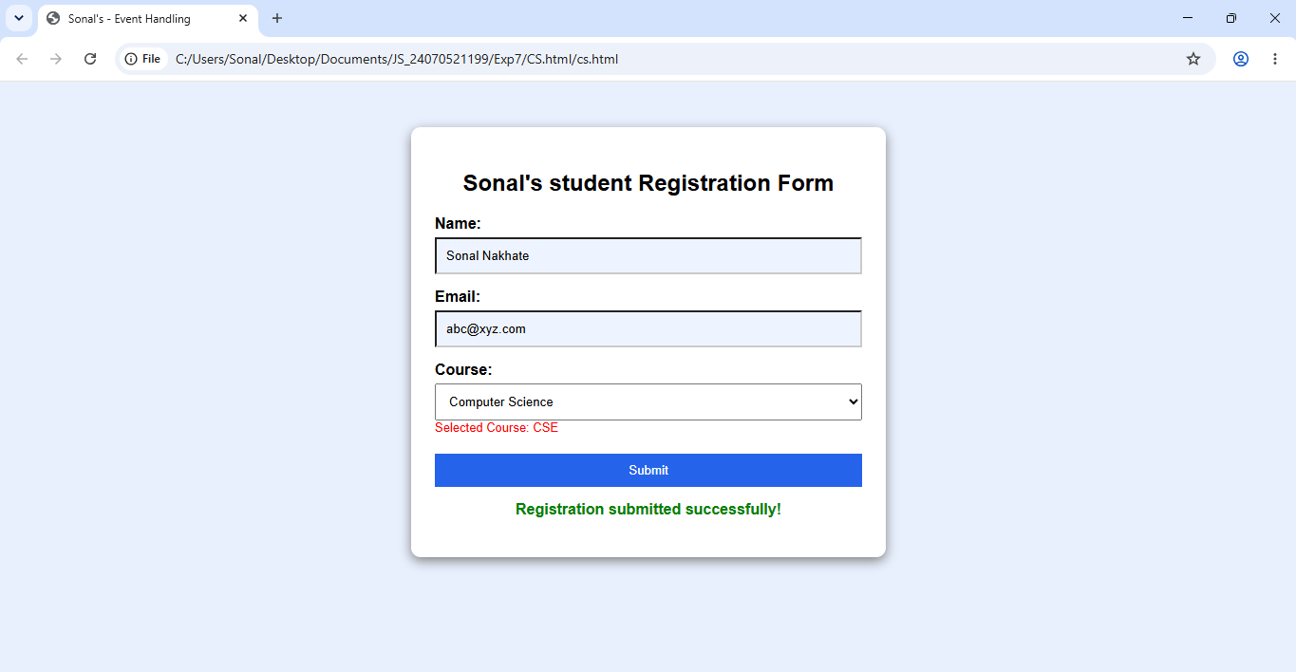

4. Result/Conclusion: This experiment demonstrated the core mechanics of JavaScript arrays and iterative processing. Highlighting how different methods handle data manipulation, transformation, and evaluation. Modifying arrays using push(), pop(), shift(), unshift(), splice(), and slice() established a practical understanding of element positioning and the distinction between mutating original data versus returning new copies. Furthermore, utilizing functional array methods like forEach(), map(), filter(), and reduce() illustrated a clean, declarative alternative to traditional looping for transforming and aggregating data. Finally, calculating the maximum and minimum values of a number array using Math.max()/Math.min() with the spread operator, reduce(), and classic for loops demonstrated how algorithmic logic and modern language features can solve fundamental computational problems efficiently.

Experiment No.: 7

1. Title: Perform DOM traversal and updates; develop a to-do list app with add, edit, and delete features.

2. Software/Tools Required: Visual Studio Code (VS
Code), HTML, CSS, JavaScript.

3. Theory: DOM (Document Object Model) traversal and manipulation allow JavaScript to dynamically select, structure, and modify webpage content without requiring a full page refresh.
- DOM Traversal: Involves navigating through parent, child, and sibling nodes using methods like getElementById(), createElement(), and appendChild().
- Dynamic DOM Updates: Enables creating elements on the fly (createElement('li')), assigning inline/CSS classes (classList.toggle('completed')), and removing elements from the node tree (li.remove()).
- Event Handling: Listens for user interactions (click, keypress) using addEventListener() to trigger functions that mutate the structure and appearance of the page in real time.

4. Output:

5. Result/Conclusion: The To-Do List application demonstrates how JavaScript interacts with the DOM tree to construct interactive web interfaces. By combining event listeners with DOM traversal, creation, and deletion methods, the application handles user inputs, dynamically updates task statuses, and modifies the DOM structure seamlessly.

Case Study No.: 7

1. Case Study Title: To demonstrate events handling in javascript, a) access and manipulate from elements using javascript. b) validate user input (eg. email,empty,fields) c) use various form events (submit,change,focus).

2. Case Study Program Code:
//Sonal Nakhate 24070521199

<!DOCTYPE html>
<html>
<head>
<title>Sonal's - Event Handling</title>

<style>
body {
font-family: Arial, sans-serif;
background-color: #e8f0fe;
padding: 40px;
}

.form-box {
width: 450px;
margin: auto;
background-color: white;
padding: 25px;
border-radius: 10px;
box-shadow: 0 4px 12px gray;
}

h2 {
text-align: center;
}

label {
display: block;
margin-top: 15px;
font-weight: bold;
}

input, select {
width: 100%;
padding: 10px;
margin-top: 5px;
box-sizing: border-box;
}

input:focus, select:focus {
border: 2px solid blue;
outline: none;
}

.error {
color: red;
font-size: 13px;
}

button {
width: 100%;
margin-top: 20px;
padding: 10px;
background-color: #2563eb;
color: white;
border: none;
cursor: pointer;
}

#message {
text-align: center;
font-weight: bold;
margin-top: 15px;
}
</style>
</head>

<body>

<div class="form-box">

<h2>Sonal's student Registration Form</h2>

<form id="studentForm">

<label>Name:</label>
<input type="text" id="name">
<div id="nameError" class="error"></div>

<label>Email:</label>
<input type="text" id="email">
<div id="emailError" class="error"></div>

<label>Course:</label>
<select id="course">
<option value="">Select Course</option>
<option value="CSE">Computer Science</option>
<option value="IT">Information Technology</option>
<option value="ECE">Electronics</option>
</select>
<div id="courseError" class="error"></div>

<button type="submit">Submit</button>

</form>

<p id="message"></p>

</div>

<script>

// Access form elements
let form = document.getElementById("studentForm");
let name = document.getElementById("name");
let email = document.getElementById("email");
let course = document.getElementById("course");

// Focus event
name.addEventListener("focus", function() {
name.style.backgroundColor = "#eef4ff";
});

email.addEventListener("focus", function() {
email.style.backgroundColor = "#eef4ff";
});

// Change event
course.addEventListener("change", function() {
document.getElementById("courseError").innerText =
"Selected Course: " + course.value;
});

// Submit event
form.addEventListener("submit", function(event) {

event.preventDefault();

let valid = true;

// Name validation
if (name.value.trim() === "") {
document.getElementById("nameError").innerText =
"Name cannot be empty";
valid = false;
} else {
document.getElementById("nameError").innerText = "";
}

// Email validation
let emailPattern = /^[^\s@]+@[^\s@]+\.[^\s@]+$/;

if (email.value.trim() === "") {
document.getElementById("emailError").innerText =
"Email cannot be empty";
valid = false;
}
else if (!emailPattern.test(email.value)) {
document.getElementById("emailError").innerText =
"Enter a valid email";
valid = false;
}
else {
document.getElementById("emailError").innerText = "";
}

// Course validation
if (course.value === "") {
document.getElementById("courseError").innerText =
"Please select a course";
valid = false;
}

// Final result
if (valid) {
document.getElementById("message").innerText =
"Registration submitted successfully!";
document.getElementById("message").style.color = "green";
}
else {
document.getElementById("message").innerText =
"Please correct the errors.";
document.getElementById("message").style.color = "red";
}

});

</script>

</body>
</html>

3. Output:

4. Result/Conclusion: Thus, JavaScript events were successfully handled using focus, change, and submit, and form elements were accessed, manipulated, and validated using JavaScript.

Experiment No.: 8

1. Title: Access and validate form fields using events; design a gym admission form with live input checks.

2. Software/Tools Required: Visual Studio Code (VS
Code), HTML, CSS, JavaScript.

3. Theory: Event-driven validation in web applications relies on JavaScript event listeners to continuously monitor user interaction with form controls.
Instead of waiting for a manual form submission, events like input detect live changes as a user types, while change identifies selections made in controls like dropdowns. When triggered, these events execute handler functions that evaluate the input against defined criteria—such as string length, numeric range limits, or regular expressions for email and phone numbers—and update the Document Object Model (DOM) dynamically.
This direct feedback loop improves user experience by providing immediate visual indicators and prevents invalid data submission before the final submit event processes the payload.

4. Output:
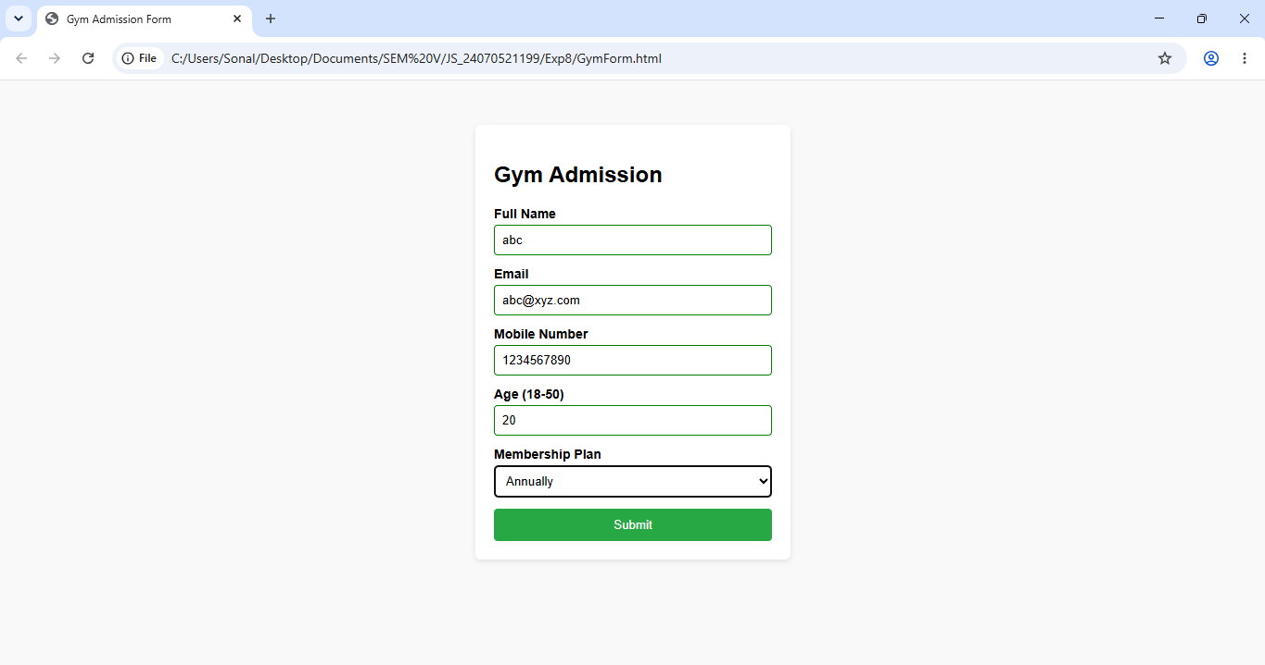

5. Result/Conclusion: The implementation of the gym admission form successfully demonstrates the practical application of client-side, event-driven validation using JavaScript. By attaching input and change event listeners to individual input fields, the application delivers real-time user feedback, effectively highlighting errors and guiding correct data entry for names, emails, contact numbers, age constraints, and membership selections. Overall, this approach enforces strict data integrity before submission, minimizes form errors, and significantly enhances overall usability compared to traditional static form handling.

Case Study No.: 8

1. Case Study Title: Online Job Application Form, A company wants to create an online job application form that checks the entered information immediately and prevents submission when the details are invalid.

2. Case Study Program Code:
//Sonal Nakhate 24070521199

<!DOCTYPE html>
<html lang="en">
<head>
<meta charset="UTF-8">
<title>Sonal's Online Job Application Form</title>
<style>
body {
background-color: #dce7ff;
font-family: Arial, sans-serif;
display: flex;
justify-content: center;
padding: 20px 0;
}

.form-card {
background-color: #ffffff;
width: 550px;
padding: 25px 30px;
border-radius: 12px;
box-shadow: 0 4px 15px rgba(0,0,0,0.1);
}

h2 {
text-align: center;
color: #2b2b80;
margin-top: 0;
}

.section-title {
color: #4343ff;
font-size: 18px;
font-weight: bold;
margin-top: 20px;
margin-bottom: 10px;
border-bottom: 1px solid #ddd;
padding-bottom: 5px;
}

.form-group {
margin-bottom: 15px;
}

label {
display: block;
font-weight: bold;
font-size: 14px;
margin-bottom: 5px;
}

input[type="text"],
input[type="date"],
input[type="number"],
select,
textarea {
width: 100%;
padding: 10px;
border: 1px solid #ccc;
border-radius: 6px;
box-sizing: border-box;
font-size: 14px;
}

textarea {
height: 70px;
resize: vertical;
}

.radio-group {
display: flex;
gap: 15px;
align-items: center;
font-size: 14px;
}

.radio-group input {
margin-right: 5px;
}

.msg {
font-size: 12px;
margin-top: 4px;
font-weight: bold;
}

.msg.valid {
color: #1a8a2a;
}

.msg.invalid {
color: #ff0000;
}

.submit-btn {
width: 100%;
padding: 12px;
background-color: #4343ff;
color: white;
border: none;
border-radius: 6px;
font-size: 16px;
font-weight: bold;
cursor: pointer;
margin-top: 20px;
}

.submit-btn:hover {
background-color: #2b2b80;
}

#form-status {
text-align: center;
font-weight: bold;
margin-top: 15px;
font-size: 14px;
}
</style>
</head>
<body>

<div class="form-card">
<h2>💼 Sonal Online Job Application Form</h2>

<form id="jobForm">
<!-- Personal Information -->
<div class="section-title">Personal Information</div>

<div class="form-group">
<label>Full Name:</label>
<input type="text" id="fullName" placeholder="Enter full name">
<div id="fullNameMsg" class="msg"></div>
</div>

<div class="form-group">
<label>Date of Birth:</label>
<input type="date" id="dob">
<div id="dobMsg" class="msg"></div>
</div>

<div class="form-group">
<label>Gender:</label>
<div class="radio-group">
<label><input type="radio" name="gender" value="Male"> Male</label>
<label><input type="radio" name="gender" value="Female"> Female</label>
<label><input type="radio" name="gender" value="Other"> Other</label>
</div>
<div id="genderMsg" class="msg"></div>
</div>

<div class="form-group">
<label>Email Address:</label>
<input type="text" id="email" placeholder="Enter email address">
<div id="emailMsg" class="msg"></div>
</div>

<div class="form-group">
<label>Mobile Number:</label>
<input type="text" id="mobile" placeholder="Enter mobile number">
<div id="mobileMsg" class="msg"></div>
</div>

<div class="form-group">
<label>Address:</label>
<textarea id="address" placeholder="Enter address"></textarea>
<div id="addressMsg" class="msg"></div>
</div>

<div class="form-group">
<label>City:</label>
<input type="text" id="city" placeholder="Enter city">
<div id="cityMsg" class="msg"></div>
</div>

<div class="form-group">
<label>State:</label>
<input type="text" id="state" placeholder="Enter state">
<div id="stateMsg" class="msg"></div>
</div>

<div class="form-group">
<label>PIN Code:</label>
<input type="text" id="pincode" placeholder="Enter 6-digit PIN code">
<div id="pincodeMsg" class="msg"></div>
</div>

<div class="form-group">
<label>Educational Qualification:</label>
<select id="qualification">
<option value="">Select Qualification</option>
<option value="B.Tech">B.Tech</option>
<option value="B.Sc">B.Sc</option>
<option value="M.Tech">M.Tech</option>
<option value="Other">Other</option>
</select>
<div id="qualificationMsg" class="msg"></div>
</div>

<div class="form-group">
<label>Percentage:</label>
<input type="number" id="percentage" placeholder="Enter percentage">
<div id="percentageMsg" class="msg"></div>
</div>

<div class="form-group">
<label>Passing Year:</label>
<input type="number" id="passingYear" placeholder="Enter passing year">
<div id="passingYearMsg" class="msg"></div>
</div>

<!-- Professional Information -->
<div class="section-title">Professional Information</div>

<div class="form-group">
<label>Applying for Job Position:</label>
<input type="text" id="jobPosition" placeholder="Enter job position">
<div id="jobPositionMsg" class="msg"></div>
</div>

<div class="form-group">
<label>Total Work Experience (Years):</label>
<input type="number" id="experience" placeholder="Enter work experience">
<div id="experienceMsg" class="msg"></div>
</div>

<div class="form-group">
<label>Current / Previous Organization:</label>
<input type="text" id="organization" placeholder="Enter organization name">
<div id="organizationMsg" class="msg"></div>
</div>

<div class="form-group">
<label>Current Designation:</label>
<input type="text" id="designation" placeholder="Enter designation">
<div id="designationMsg" class="msg"></div>
</div>

<div class="form-group">
<label>Expected Salary:</label>
<input type="number" id="salary" placeholder="Enter expected salary">
<div id="salaryMsg" class="msg"></div>
</div>

<div class="form-group">
<label>Technical Skills:</label>
<textarea id="skills" placeholder="Enter technical skills"></textarea>
<div id="skillsMsg" class="msg"></div>
</div>

<button type="button" class="submit-btn" onclick="validateForm()">Submit Application</button>

<div id="form-status"></div>
</form>
</div>

<script>
// Helper function to update feedback messages
function setMsg(elementId, text, isValid) {
let msgElement = document.getElementById(elementId);
msgElement.innerHTML = (isValid ? "✓ " : "") + text;
msgElement.className = "msg " + (isValid ? "valid" : "invalid");
}

function validateFullName() {
let val = document.getElementById("fullName").value.trim();
if (val.length >= 2) {
setMsg("fullNameMsg", "Valid name", true);
return true;
} else {
setMsg("fullNameMsg", "Invalid name", false);
return false;
}
}

function validateDOB() {
let val = document.getElementById("dob").value;
if (val !== "") {
setMsg("dobMsg", "Date of birth selected", true);
return true;
} else {
setMsg("dobMsg", "Please select date of birth", false);
return false;
}
}

function validateGender() {
let selected = document.querySelector('input[name="gender"]:checked');
if (selected) {
setMsg("genderMsg", "Gender selected", true);
return true;
} else {
setMsg("genderMsg", "Please select gender", false);
return false;
}
}

function validateEmail() {
let val = document.getElementById("email").value.trim();
let emailPattern = /^[^\s@]+@[^\s@]+\.[^\s@]+$/;
if (emailPattern.test(val)) {
setMsg("emailMsg", "Valid email address", true);
return true;
} else {
setMsg("emailMsg", "Invalid email address", false);
return false;
}
}

function validateMobile() {
let val = document.getElementById("mobile").value.trim();
if (/^\d{10}$/.test(val)) {
setMsg("mobileMsg", "Valid mobile number", true);
return true;
} else {
setMsg("mobileMsg", "Invalid mobile number - enter 10 digits", false);
return false;
}
}

function validateAddress() {
let val = document.getElementById("address").value.trim();
if (val.length > 5) {
setMsg("addressMsg", "Valid address", true);
return true;
} else {
setMsg("addressMsg", "Invalid address", false);
return false;
}
}

function validateCity() {
let val = document.getElementById("city").value.trim();
if (val.length >= 2) {
setMsg("cityMsg", "Valid city", true);
return true;
} else {
setMsg("cityMsg", "Invalid city", false);
return false;
}
}

function validateState() {
let val = document.getElementById("state").value.trim();
if (val.length >= 2) {
setMsg("stateMsg", "Valid state", true);
return true;
} else {
setMsg("stateMsg", "Invalid state", false);
return false;
}
}

function validatePincode() {
let val = document.getElementById("pincode").value.trim();
if (/^\d{6}$/.test(val)) {
setMsg("pincodeMsg", "Valid PIN code", true);
return true;
} else {
setMsg("pincodeMsg", "Invalid PIN - enter 6 digits", false);
return false;
}
}

function validateQualification() {
let val = document.getElementById("qualification").value;
if (val !== "") {
setMsg("qualificationMsg", "Qualification selected", true);
return true;
} else {
setMsg("qualificationMsg", "Please select qualification", false);
return false;
}
}

function validatePercentage() {
let val = Number(document.getElementById("percentage").value);
if (val > 0 && val <= 100) {
setMsg("percentageMsg", "Valid percentage", true);
return true;
} else {
setMsg("percentageMsg", "Invalid percentage", false);
return false;
}
}

function validatePassingYear() {
let val = Number(document.getElementById("passingYear").value);
let currentYear = new Date().getFullYear();
if (val >= 1970 && val <= currentYear) {
setMsg("passingYearMsg", "Valid passing year", true);
return true;
} else {
setMsg("passingYearMsg", "Invalid passing year", false);
return false;
}
}

function validateJobPosition() {
let val = document.getElementById("jobPosition").value.trim();
if (val.length >= 2) {
setMsg("jobPositionMsg", "Valid job position", true);
return true;
} else {
setMsg("jobPositionMsg", "Invalid job position", false);
return false;
}
}

function validateExperience() {
let val = document.getElementById("experience").value;
if (val !== "" && Number(val) >= 0) {
setMsg("experienceMsg", "Valid experience", true);
return true;
} else {
setMsg("experienceMsg", "Experience cannot be negative", false);
return false;
}
}

function validateOrganization() {
let val = document.getElementById("organization").value.trim();
if (val.length >= 2) {
setMsg("organizationMsg", "Valid organization", true);
return true;
} else {
setMsg("organizationMsg", "Invalid organization", false);
return false;
}
}

function validateDesignation() {
let val = document.getElementById("designation").value.trim();
if (val.length >= 2) {
setMsg("designationMsg", "Valid designation", true);
return true;
} else {
setMsg("designationMsg", "Invalid designation", false);
return false;
}
}

function validateSalary() {
let val = Number(document.getElementById("salary").value);
if (val > 0) {
setMsg("salaryMsg", "Valid expected salary", true);
return true;
} else {
setMsg("salaryMsg", "Invalid expected salary", false);
return false;
}
}

function validateSkills() {
let val = document.getElementById("skills").value.trim();
if (val.length >= 2) {
setMsg("skillsMsg", "Skills entered", true);
return true;
} else {
setMsg("skillsMsg", "Please enter skills", false);
return false;
}
}

// Attach real-time validation event listeners
document.getElementById("fullName").addEventListener("input", validateFullName);
document.getElementById("dob").addEventListener("change", validateDOB);
document.querySelectorAll('input[name="gender"]').forEach(radio => radio.addEventListener("change", validateGender));
document.getElementById("email").addEventListener("input", validateEmail);
document.getElementById("mobile").addEventListener("input", validateMobile);
document.getElementById("address").addEventListener("input", validateAddress);
document.getElementById("city").addEventListener("input", validateCity);
document.getElementById("state").addEventListener("input", validateState);
document.getElementById("pincode").addEventListener("input", validatePincode);
document.getElementById("qualification").addEventListener("change", validateQualification);
document.getElementById("percentage").addEventListener("input", validatePercentage);
document.getElementById("passingYear").addEventListener("input", validatePassingYear);
document.getElementById("jobPosition").addEventListener("input", validateJobPosition);
document.getElementById("experience").addEventListener("input", validateExperience);
document.getElementById("organization").addEventListener("input", validateOrganization);
document.getElementById("designation").addEventListener("input", validateDesignation);
document.getElementById("salary").addEventListener("input", validateSalary);
document.getElementById("skills").addEventListener("input", validateSkills);

// Global form submission check
function validateForm() {
let isAllValid =
validateFullName() &
validateDOB() &
validateGender() &
validateEmail() &
validateMobile() &
validateAddress() &
validateCity() &
validateState() &
validatePincode() &
validateQualification() &
validatePercentage() &
validatePassingYear() &
validateJobPosition() &
validateExperience() &
validateOrganization() &
validateDesignation() &
validateSalary() &
validateSkills();

let statusDiv = document.getElementById("form-status");

if (isAllValid) {
statusDiv.style.color = "#1a8a2a";
statusDiv.innerHTML = "✓ Application submitted successfully!";
} else {
statusDiv.style.color = "#ff0000";
statusDiv.innerHTML = "✖ Please correct the invalid details before submitting.";
}
}
</script>

</body>
</html>

3. Output:
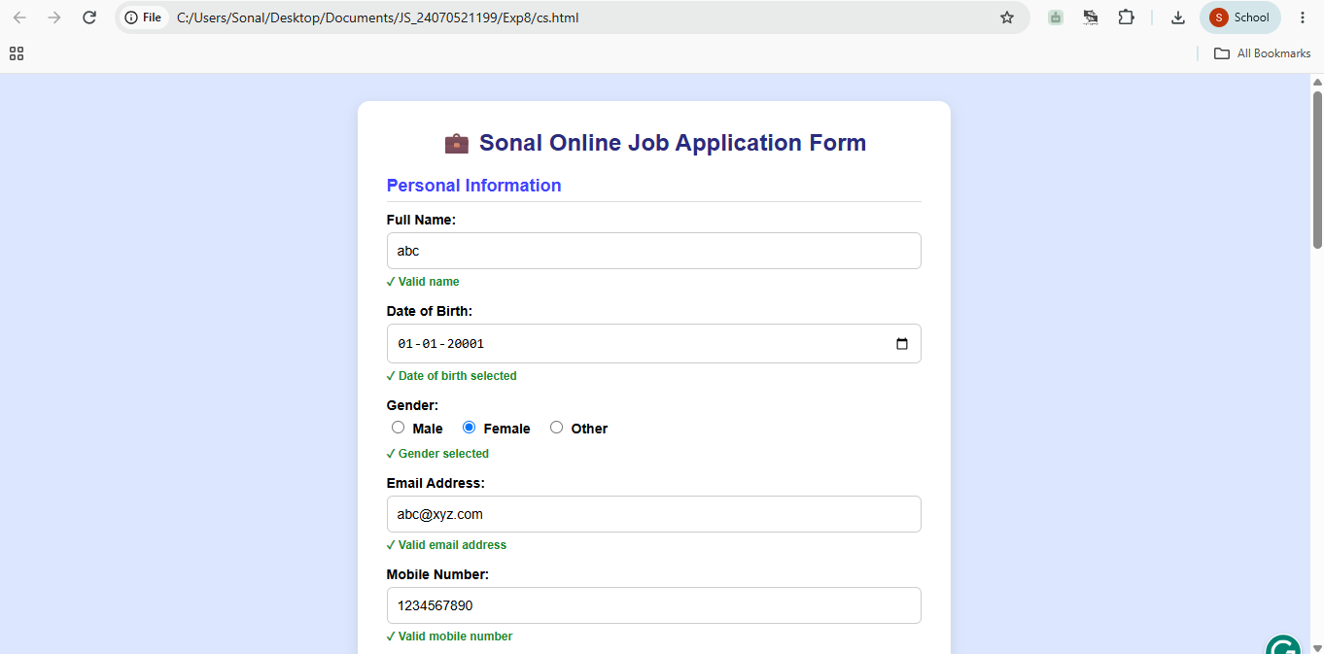
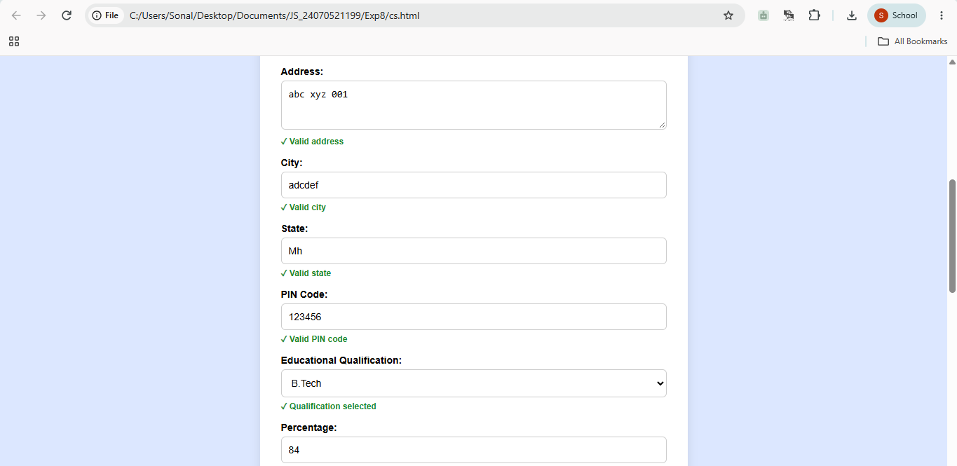
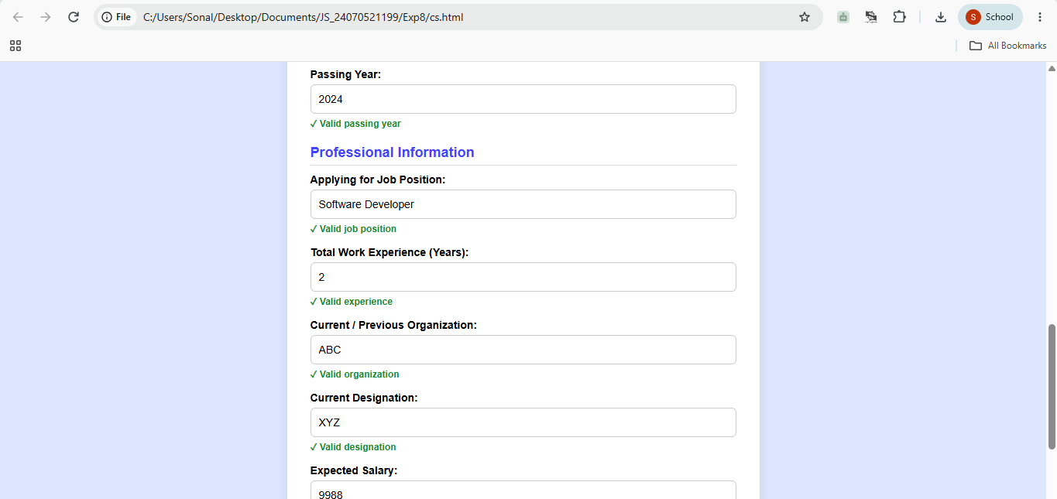
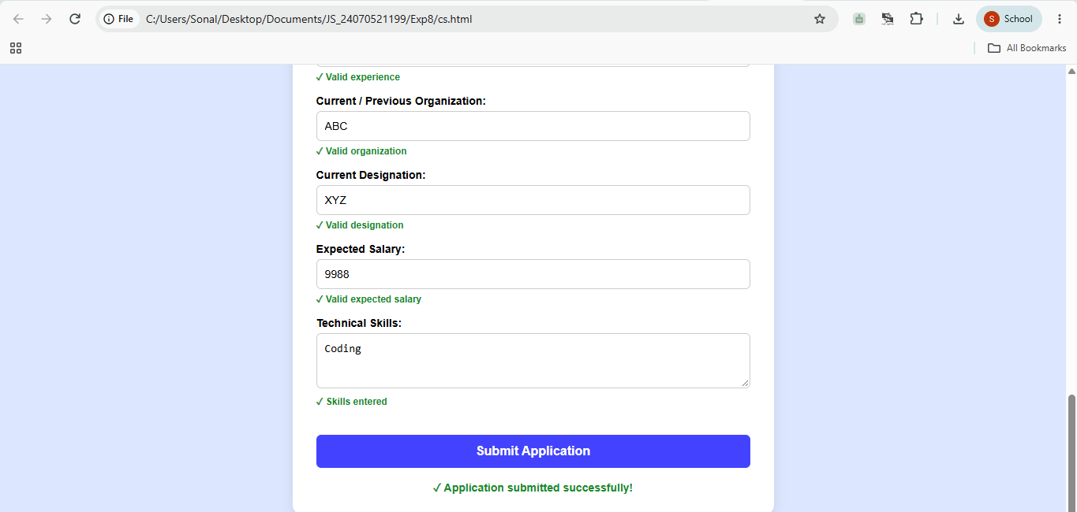

4. Result/Conclusion: Thus, an online job application form was successfully created with live validation to check user details and prevent invalid form submission.

Experiment No.: 9

1. Title: Access and validate form fields using events; design a gym admission form with live input checks.

2. Software/Tools Required: Visual Studio Code (VS
Code), HTML, CSS, JavaScript.

3. Theory: Event-driven validation in web applications relies on JavaScript event listeners to continuously monitor user interaction with form controls.
Instead of waiting for a manual form submission, events like input detect live changes as a user types, while change identifies selections made in controls like dropdowns. When triggered, these events execute handler functions that evaluate the input against defined criteria—such as string length, numeric range limits, or regular expressions for email and phone numbers—and update the Document Object Model (DOM) dynamically.
This direct feedback loop improves user experience by providing immediate visual indicators and prevents invalid data submission before the final submit event processes the payload.

4. Output:

5. Result/Conclusion: The implementation of the gym admission form successfully demonstrates the practical application of client-side, event-driven validation using JavaScript. By attaching input and change event listeners to individual input fields, the application delivers real-time user feedback, effectively highlighting errors and guiding correct data entry for names, emails, contact numbers, age constraints, and membership selections. Overall, this approach enforces strict data integrity before submission, minimizes form errors, and significantly enhances overall usability compared to traditional static form handling.
Case Study No.: 9

1. Case Study Title: Common Case Study Scenario for Practical 1-8
Develop a Student Task Management Web Application and apply Dark Theme and Light Theme functionality across all practicals 1-8.
The application should allow users to perform the activities covered in Practical 1-8, such as creating and managing tasks, updating content using DOM operations, handling user interactions, validating inputs, and dynamically modifying webpage elements.
• A Theme Toggle Button should be included in every practical application, allowing users to switch between Light Mode and Dark Mode. The selected theme should be saved using LocalStorage, so the user's preference remains available even after closing and reopening the browser.

2. Case Study Program Code:

<!DOCTYPE html>
<!-- Sonal Nakhate 24070521199 -->
<html lang="en">
<head>
<meta charset="UTF-8">
<meta name="viewport" content="width=device-width, initial-scale=1.0">
<title>Gym Admission Form</title>
<style>
/* CSS Theme Variables */
:root {
--bg-color: #f4f4f9;
--text-color: #333333;
--card-bg: #ffffff;
--border-color: #cccccc;
--input-bg: #ffffff;
--label-color: #555555;
--box-shadow: 0 4px 10px rgba(0, 0, 0, 0.1);
}

[data-theme="dark"] {
--bg-color: #121212;
--text-color: #f0f0f0;
--card-bg: #1e1e1e;
--border-color: #444444;
--input-bg: #2d2d2d;
--label-color: #bbbbbb;
--box-shadow: 0 4px 10px rgba(0, 0, 0, 0.5);
}

[data-theme="light"] {
--bg-color: #f4f4f9;
--text-color: #333333;
--card-bg: #ffffff;
--border-color: #cccccc;
--input-bg: #ffffff;
--label-color: #555555;
--box-shadow: 0 4px 10px rgba(0, 0, 0, 0.1);
}

body {
font-family: Arial, sans-serif;
background-color: var(--bg-color);
color: var(--text-color);
display: flex;
flex-direction: column;
justify-content: center;
align-items: center;
min-height: 100vh;
margin: 0;
padding: 20px 0;
box-sizing: border-box;
transition: background-color 0.3s, color 0.3s;
}

.theme-selector {
width: 100%;
max-width: 400px;
margin-bottom: 15px;
}

.form-container {
background: var(--card-bg);
padding: 25px 30px;
border-radius: 8px;
box-shadow: var(--box-shadow);
width: 100%;
max-width: 400px;
border: 1px solid var(--border-color);
box-sizing: border-box;
transition: background-color 0.3s, border-color 0.3s;
}

h2 {
text-align: center;
color: var(--text-color);
margin-bottom: 20px;
}

.form-group {
margin-bottom: 15px;
}

label {
display: block;
font-weight: bold;
margin-bottom: 5px;
color: var(--label-color);
}

input, select {
width: 100%;
padding: 10px;
border: 1px solid var(--border-color);
border-radius: 4px;
box-sizing: border-box;
font-size: 14px;
background-color: var(--input-bg);
color: var(--text-color);
}

input:focus, select:focus {
outline: none;
border-color: #007bff;
}

.error {
color: #dc3545;
font-size: 12px;
margin-top: 5px;
display: block;
min-height: 15px;
}

.valid {
border-color: #28a745 !important;
}

.invalid {
border-color: #dc3545 !important;
}

button {
width: 100%;
padding: 12px;
background-color: #007bff;
color: white;
border: none;
border-radius: 4px;
font-size: 16px;
font-weight: bold;
cursor: pointer;
}

button:hover {
background-color: #0056b3;
}

.success-msg {
color: #28a745;
text-align: center;
font-weight: bold;
margin-top: 15px;
}
</style>
</head>
<body>

<!-- Theme Selector Control -->
<div class="theme-selector">
<label for="themeSelect"><strong>Theme: </strong></label>
<select id="themeSelect" onchange="applyTheme(this.value)">
<option value="default" selected>System Default</option>
<option value="light">Light</option>
<option value="dark">Dark</option>
</select>
</div>

<div class="form-container">
<h2>Gym Admission Form</h2>
<form id="gymForm" novalidate>

<!-- Full Name -->
<div class="form-group">
<label for="fullName">Full Name</label>
<input type="text" id="fullName" placeholder="Enter your full name">
<span class="error" id="nameError"></span>
</div>

<!-- Email Address -->
<div class="form-group">
<label for="email">Email Address</label>
<input type="email" id="email" placeholder="abc@xyz.com">
<span class="error" id="emailError"></span>
</div>

<!-- Mobile Number -->
<div class="form-group">
<label for="mobile">Mobile Number</label>
<input type="tel" id="mobile" placeholder="10-digit mobile number">
<span class="error" id="mobileError"></span>
</div>

<!-- Age -->
<div class="form-group">
<label for="age">Age (18 - 50)</label>
<input type="number" id="age" placeholder="Enter your age">
<span class="error" id="ageError"></span>
</div>

<!-- Membership Plan -->
<div class="form-group">
<label for="plan">Membership Plan</label>
<select id="plan">
<option value="">-- Select a Plan --</option>
<option value="quarterly">Quarterly</option>
<option value="half-yearly">Half Yearly</option>
<option value="annually">Annually</option>
</select>
<span class="error" id="planError"></span>
</div>

<button type="submit">Submit Admission</button>
<div id="successMsg" class="success-msg"></div>
</form>
</div>

<script>
// Theme Switcher Logic
function applyTheme(theme) {
const root = document.documentElement;
if (theme === "default") {
const prefersDark = window.matchMedia("(prefers-color-scheme: dark)").matches;
root.setAttribute("data-theme", prefersDark ? "dark" : "light");
} else {
root.setAttribute("data-theme", theme);
}
}

// Apply default theme on page load
applyTheme("default");

// Get element references
const fullName = document.getElementById('fullName');
const email = document.getElementById('email');
const mobile = document.getElementById('mobile');
const age = document.getElementById('age');
const plan = document.getElementById('plan');
const gymForm = document.getElementById('gymForm');

// Helper function to update input styling and error message
function setValidationState(input, errorElement, isValid, errorMessage) {
if (isValid) {
input.classList.remove('invalid');
input.classList.add('valid');
errorElement.textContent = '';
return true;
} else {
input.classList.remove('valid');
input.classList.add('invalid');
errorElement.textContent = errorMessage;
return false;
}
}

// --- Live Validation Functions ---

function validateName() {
const value = fullName.value.trim();
const isValid = value.length >= 3;
return setValidationState(
fullName,
document.getElementById('nameError'),
isValid,
'Name must be at least 3 characters long.'
);
}

function validateEmail() {
const value = email.value.trim();
// Basic email pattern regex
const emailRegex = /^[^\s@]+@[^\s@]+\.[^\s@]+$/;
const isValid = emailRegex.test(value);
return setValidationState(
email,
document.getElementById('emailError'),
isValid,
'Please enter a valid email address.'
);
}

function validateMobile() {
const value = mobile.value.trim();
// Validates a 10-digit phone number
const mobileRegex = /^[0-9]{10}$/;
const isValid = mobileRegex.test(value);
return setValidationState(
mobile,
document.getElementById('mobileError'),
isValid,
'Please enter a valid 10-digit mobile number.'
);
}

function validateAge() {
const value = parseInt(age.value, 10);
const isValid = !isNaN(value) && value >= 18 && value <= 50;
return setValidationState(
age,
document.getElementById('ageError'),
isValid,
'Age must be between 18 and 50.'
);
}

function validatePlan() {
const isValid = plan.value !== '';
return setValidationState(
plan,
document.getElementById('planError'),
isValid,
'Please select a membership plan.'
);
}

// --- Attach Event Listeners for Live Checks ---

fullName.addEventListener('input', validateName);
email.addEventListener('input', validateEmail);
mobile.addEventListener('input', validateMobile);
age.addEventListener('input', validateAge);
plan.addEventListener('change', validatePlan);

// 'submit' event to validate all fields before sending form data
gymForm.addEventListener('submit', function (event) {
event.preventDefault(); // Prevent page reload

// Run all validations
const isNameValid = validateName();
const isEmailValid = validateEmail();
const isMobileValid = validateMobile();
const isAgeValid = validateAge();
const isPlanValid = validatePlan();

// Check if all fields are valid
if (isNameValid && isEmailValid && isMobileValid && isAgeValid && isPlanValid) {
document.getElementById('successMsg').textContent = 'Admission Submitted Successfully!';
gymForm.reset(); // Reset fields

// Clear visual validation indicators
[fullName, email, mobile, age, plan].forEach(input => {
input.classList.remove('valid');
});
} else {
document.getElementById('successMsg').textContent = '';
}
});
</script>

</body>
</html>

3. Output:
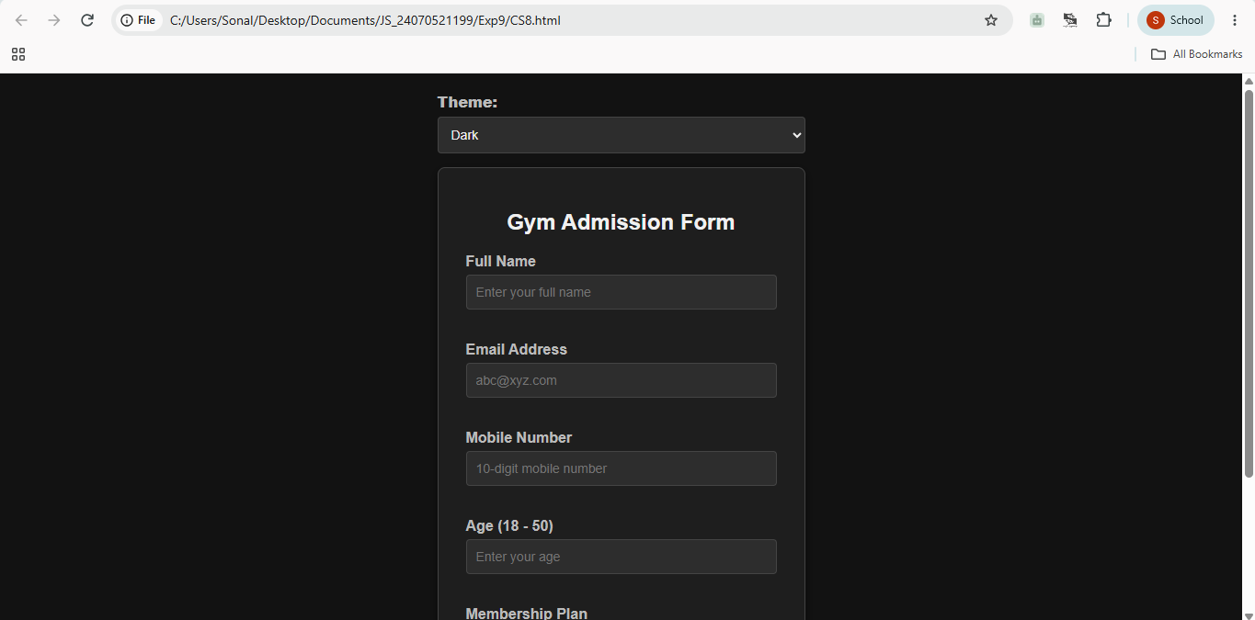
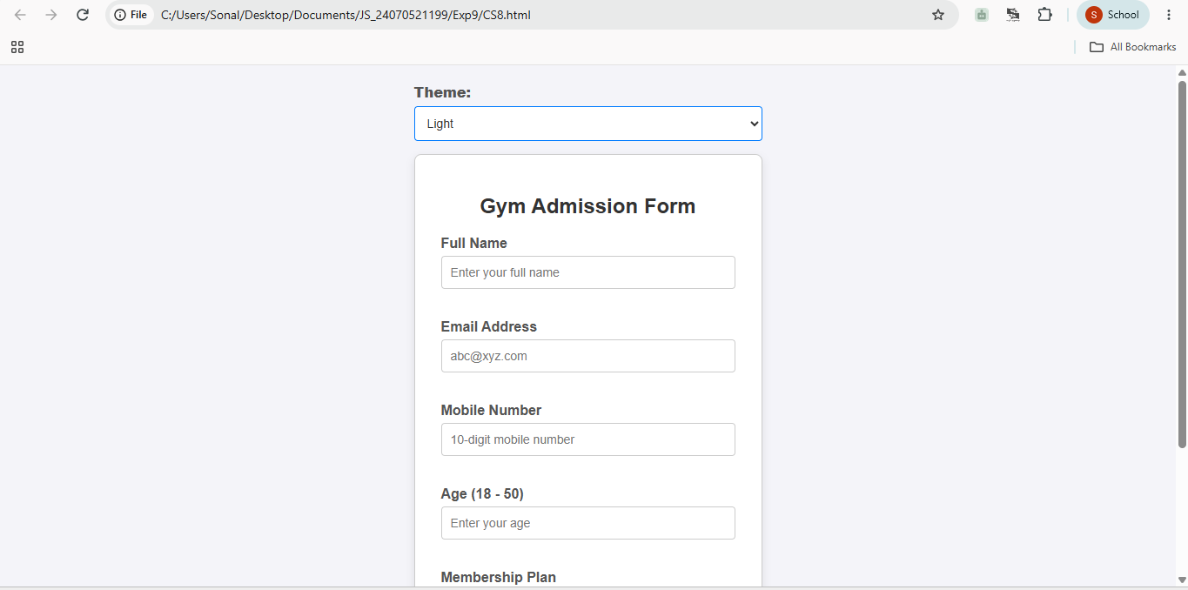

4. Result/Conclusion: Dynamic real-time form validation was successfully executed using input, change, and submit event listeners without forcing full page reloads.
Flexible theme switching was successfully integrated using CSS variables and JS-driven data-theme attribute manipulation on the root HTML element.

Experiment No.: 10

1. Title: Implement local storage and session storage to save user preferences like theme settings.

2. Software/Tools Required: Visual Studio Code (VS
Code), HTML, CSS, JavaScript.

3. Theory: Web browsers provide two primary Web Storage APIs for saving key-value pairs directly on a user's client machine: localStorage and sessionStorage.
- localStorage (Persistent Storage):
  - Lifetime: Data persists indefinitely with no expiration date. It remains stored even when the browser tab or window is closed, or the operating system is restarted.
  - Scope: Shared across all tabs, windows, and frames opened on the exact same origin (same protocol, domain, and port).
  - Use Case: Long-term user preferences, such as permanent site themes (Light/Dark mode) or layout choices.
- sessionStorage (Temporary Storage):
  - Lifetime: Data lives only for the duration of the page session. It is wiped as soon as the specific browser tab or window is closed.
  - Scope: Restricted strictly to the single tab where it was created. Opening the same page in a new tab creates an entirely isolated session.
  - Use Case: Short-term data or state that shouldn't persist across visits, such as temporary filter settings, multi-step form data, or single-session options.
4. Output:
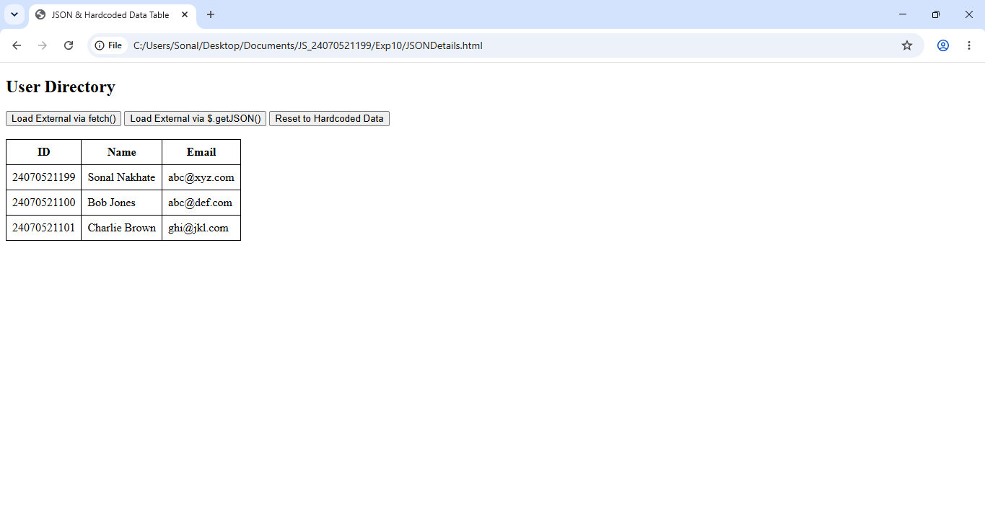

5. Result/Conclusion: Using Web Storage APIs provides a lightweight, pure client-side approach to managing state without requiring database calls or server overhead. Choosing between localStorage and sessionStorage depends entirely on data persistence requirements:
- Use localStorage when a user's preferences (like theme) should be remembered permanently across future visits.
- Use sessionStorage when preferences should reset automatically after the user finishes their current browser tab session.
- Clearing keys via removeItem() ensures a clean reset to default settings without leaving residual data in the browser
Case Study No.: 10

1. Case Study Title: A college maintains student registration data for various campus events in a JSON file. The event coordinator wants a web page that can load this information dynamically and display it in a table without manually entering the data. The student JSON file consists of Student Name, PRN, Department, Year, Event Name, and Registration Status (in a drop-down we can filter/search based on registered, pending, or cancelled) using fetch() and .$get. JSON(), display an appropriate message if JSON data cannot be loaded and no student matches the search/filter criteria.

2. Case Study Program Code:
/* Sonal Nakhate 24070521199 */
<!DOCTYPE html>
<html lang="en">
<head>
<meta charset="UTF-8">
<meta name="viewport" content="width=device-width, initial-scale=1.0">
<title>Event Registration Table</title>

<!-- Include jQuery library for $.getJSON() capability -->
<script src="https://code.jquery.com/jquery-3.7.1.min.js"></script>

<style>
body {
font-family: Arial, sans-serif;
margin: 20px;
background-color: #f8f9fa;
color: #333;
}

h2 {
color: #222;
margin-bottom: 5px;
}

p.description {
color: #666;
font-size: 14px;
margin-top: 0;
margin-bottom: 20px;
}

/* Controls Bar Styling */
.controls {
background-color: #ffffff;
padding: 15px;
border: 1px solid #ccc;
border-radius: 6px;
margin-bottom: 15px;
display: flex;
gap: 15px;
align-items: center;
flex-wrap: wrap;
}

.control-group {
display: flex;
align-items: center;
gap: 8px;
}

label {
font-weight: bold;
font-size: 14px;
}

input[type="text"], select {
padding: 6px 10px;
border: 1px solid #ccc;
border-radius: 4px;
font-size: 14px;
}

button {
padding: 7px 12px;
background-color: #007bff;
color: white;
border: none;
border-radius: 4px;
cursor: pointer;
font-size: 14px;
}

button:hover {
background-color: #0056b3;
}

button.jquery-btn {
background-color: #28a745;
}

button.jquery-btn:hover {
background-color: #218838;
}

/* Error Alert Box */
.error-msg {
background-color: #f8d7da;
color: #721c24;
padding: 12px;
border: 1px solid #f5c6cb;
border-radius: 4px;
margin-bottom: 15px;
display: none;
font-size: 14px;
}

/* Table Styling */
table {
width: 100%;
border-collapse: collapse;
background-color: #ffffff;
border: 1px solid #ccc;
}

th, td {
padding: 10px;
text-align: left;
border: 1px solid #ddd;
font-size: 14px;
}

th {
background-color: #e9ecef;
}

tr:nth-child(even) {
background-color: #f9f9f9;
}

/* Plain Text Status Badge Styling */
.status-badge {
display: inline-block;
padding: 4px 8px;
font-size: 12px;
font-weight: bold;
border-radius: 4px;
}

.status-registered {
background-color: #d4edda;
color: #155724;
border: 1px solid #c3e6cb;
}

.status-pending {
background-color: #fff3cd;
color: #856404;
border: 1px solid #ffeeba;
}

.status-cancelled {
background-color: #f8d7da;
color: #721c24;
border: 1px solid #f5c6cb;
}

.no-results-td {
text-align: center;
color: #856404;
background-color: #fff3cd;
padding: 15px;
font-weight: bold;
}
</style>
</head>
<body>

<h2>Event Registration Table</h2>
<p class="description">Student event registration manager with real-time text search and status filter dropdown.</p>

<!-- Error message display area (hidden by default) -->
<div id="errorMessage" class="error-msg"></div>

<!-- Filter & Fetch Controls -->
<div class="controls">
<div class="control-group">
<label for="searchInput">Search:</label>
<input type="text" id="searchInput" placeholder="Search name, PRN, event...">
</div>

<div class="control-group">
<label for="statusFilter">Status Filter:</label>
<select id="statusFilter">
<option value="All">All Statuses</option>
<option value="Registered">Registered</option>
<option value="Pending">Pending</option>
<option value="Cancelled">Cancelled</option>
</select>
</div>

<button onclick="loadWithFetch()">Try Load via fetch()</button>
<button class="jquery-btn" onclick="loadWithJQuery()">Try Load via $.getJSON()</button>
</div>

<!-- Registration Table -->
<table>
<thead>
<tr>
<th>Student Name</th>
<th>PRN</th>
<th>Department</th>
<th>Year</th>
<th>Event Name</th>
<th>Registration Status</th>
</tr>
</thead>
<tbody id="studentTableBody">
<!-- Dynamically filled by JavaScript -->
</tbody>
</table>

<script>
// Default master dataset loaded directly on startup
const defaultStudents = [
{
"studentName": "Aarav Sharma",
"PRN": "2024PRN001",
"department": "Computer Science",
"year": "3rd Year",
"eventName": "AI Tech Summit",
"registrationStatus": "Registered"
},
{
"studentName": "Priya Patel",
"PRN": "2024PRN002",
"department": "Information Technology",
"year": "2nd Year",
"eventName": "Cyber Security Workshop",
"registrationStatus": "Pending"
},
{
"studentName": "Rohan Deshmukh",
"PRN": "2024PRN003",
"department": "Electronics",
"year": "4th Year",
"eventName": "Robotics League 2026",
"registrationStatus": "Cancelled"
},
{
"studentName": "Ananya Roy",
"PRN": "2024PRN004",
"department": "Computer Science",
"year": "1st Year",
"eventName": "CodeSprint Hackathon",
"registrationStatus": "Registered"
},
{
"studentName": "Vikram Singh",
"PRN": "2024PRN005",
"department": "Mechanical Eng.",
"year": "3rd Year",
"eventName": "CAD Expo",
"registrationStatus": "Pending"
}
];

// Current student list displayed in memory
let students = [...defaultStudents];

// Method 1: Load external file with standard fetch() API
function loadWithFetch() {
hideError();
fetch('students.json')
.then(response => {
if (!response.ok) {
throw new Error(`HTTP ${response.status}: Failed to locate 'students.json' file.`);
}
return response.json();
})
.then(data => {
students = data;
applyFilterAndSearch();
})
.catch(error => {
showError("Error loading 'students.json' via fetch(): " + error.message);
});
}

// Method 2: Load external file with jQuery $.getJSON() API
function loadWithJQuery() {
hideError();
$.getJSON('students.json')
.done(function(data) {
students = data;
applyFilterAndSearch();
})
.fail(function(jqxhr, textStatus, error) {
showError("Error loading 'students.json' via $.getJSON(): File not found or local browser restriction.");
});
}

// Filter table by text search and dropdown status
function applyFilterAndSearch() {
const searchText = document.getElementById('searchInput').value.toLowerCase().trim();
const selectedStatus = document.getElementById('statusFilter').value;

const filteredStudents = students.filter(student => {
const matchesSearch =
student.studentName.toLowerCase().includes(searchText) ||
student.PRN.toLowerCase().includes(searchText) ||
student.department.toLowerCase().includes(searchText) ||
student.eventName.toLowerCase().includes(searchText);

const matchesStatus = (selectedStatus === "All") || (student.registrationStatus === selectedStatus);

return matchesSearch && matchesStatus;
});

renderTable(filteredStudents);
}

// Render filtered student list into table rows
function renderTable(studentList) {
const tbody = document.getElementById('studentTableBody');
tbody.innerHTML = "";

// Message when search or filter returns zero records
if (studentList.length === 0) {
tbody.innerHTML = `
<tr>
<td colspan="6" class="no-results-td">
No student matches the search/filter criteria.
</td>
</tr>`;
return;
}

studentList.forEach(student => {
let statusClass = '';
if (student.registrationStatus === 'Registered') statusClass = 'status-registered';
else if (student.registrationStatus === 'Pending') statusClass = 'status-pending';
else if (student.registrationStatus === 'Cancelled') statusClass = 'status-cancelled';

const row = document.createElement('tr');
row.innerHTML = `
<td>${student.studentName}</td>
<td>${student.PRN}</td>
<td>${student.department}</td>
<td>${student.year}</td>
<td>${student.eventName}</td>
<td>
<span class="status-badge ${statusClass}">${student.registrationStatus}</span>
</td>
`;
tbody.appendChild(row);
});
}

function showError(message) {
const errBox = document.getElementById('errorMessage');
errBox.textContent = message;
errBox.style.display = 'block';
}

function hideError() {
const errBox = document.getElementById('errorMessage');
errBox.style.display = 'none';
}

// Attach event listeners for search box and status dropdown
document.getElementById('searchInput').addEventListener('input', applyFilterAndSearch);
document.getElementById('statusFilter').addEventListener('change', applyFilterAndSearch);

// Initial page startup: render table immediately from default array
window.onload = function() {
applyFilterAndSearch();
};
</script>
</body>
</html>

3. Output:
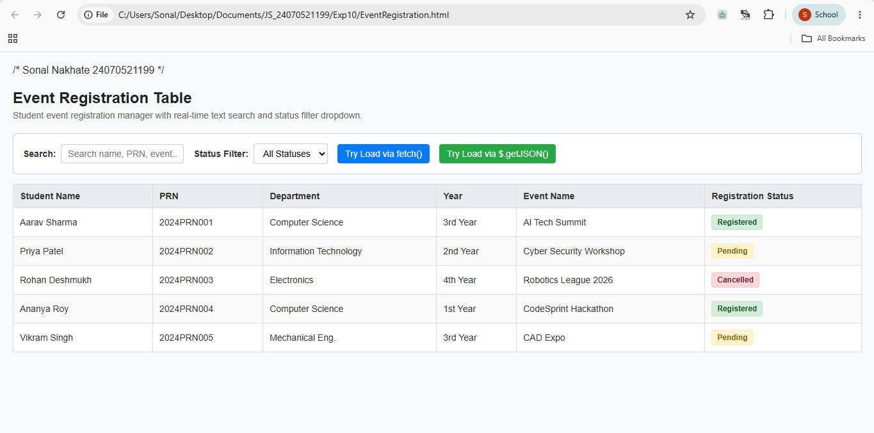
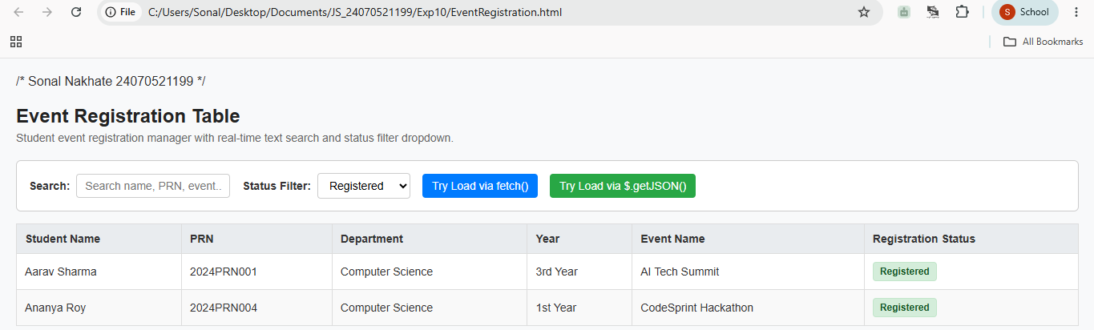
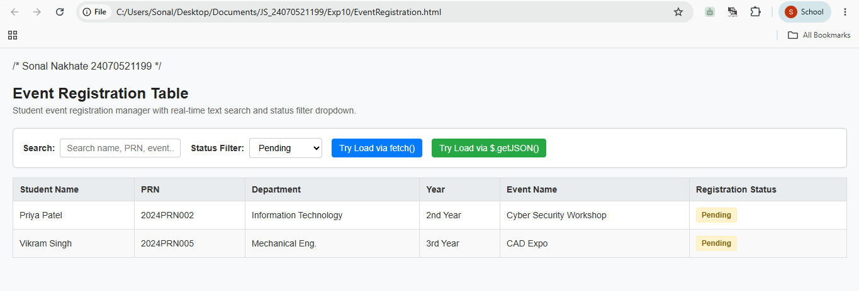
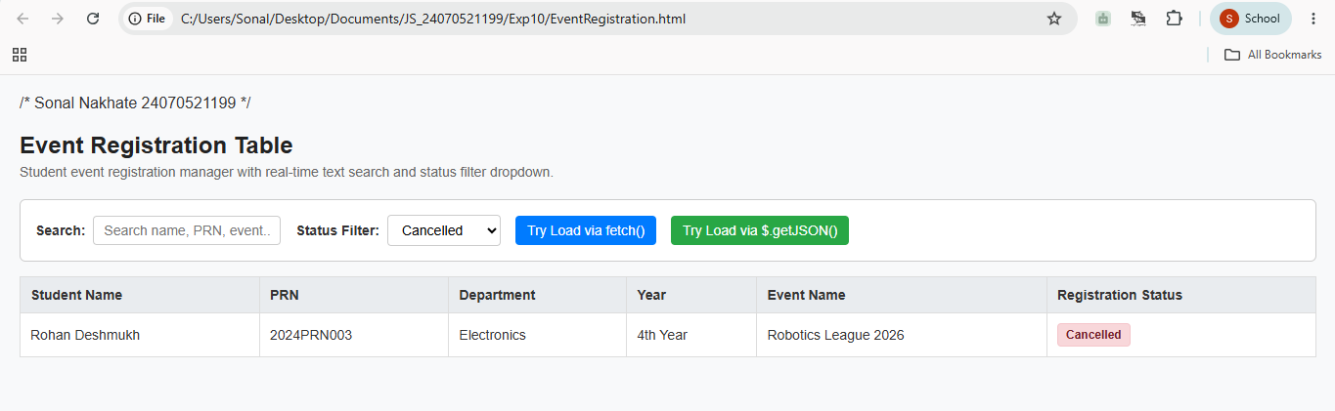

4. Result/Conclusion: This event registration web page delivers a simple, lightweight solution for event coordinators to manage student records dynamically without manual data entry.
Key Highlights:
- Flexible Data Handling: Supports both standard Vanilla JavaScript (fetch()) and jQuery ($.getJSON()) for dynamic loading, pre-loaded with fallback sample data to eliminate initial loading errors.
- Streamlined Filtering: Features real-time text search and a dedicated status dropdown (Registered, Pending, Cancelled) in the top filter bar for instant record lookup.
- Clean Table Layout: Displays student details—Name, PRN, Department, Year, Event Name, and Registration Status—as readable text badges instead of cluttered form inputs.
- Robust Error & Empty States: Provides clear, contextual alerts only when external file fetches fail or when search/filter combinations return no matching records.

